***version: 1.1***

CHAPTER

2 Sets Functions and Groups

*Animation 2.1: Function*

*Source & Credit: elearn.punjab*

**1. Quadratic Equations eLearn.Punjab 1. Quadratic Equations eLearn.Punjab *2. Sets Functions and Groups eLearn.Punjab 2. Sets Functions and Groups eLearn.Punjab***

**2.1 Introduction**

We are familiar with the notion of a **set** since the word is frequently used in everyday speech, for instance, water set, tea set, sofa set. It is a wonder that mathematicians have developed this ordinary word into a mathematical concept as much as it has become a language which is employed in most branches of modern mathematics.

For the purposes of mathematics, a set is generally described as a **well-deined collection of distinct objects.** By a *well-deined collection* is meant a collection, which is such that, given any object, we may be able to decide whether the object belongs to the collection or not. By *distinct objects* we mean objects no two of which are identical (same). The objects in a set are called its **members** or **elements**. Capital letters *A, B, C, X, Y, Z* etc., are generally used as names of sets and small letters *a, b, c, x, y, z* etc., are used as *members* of sets.



There are three diferent ways of describing a set

1. **The Descriptive Method:** A set may be described in words. For instance, the set of all vowels of the English alphabets.
2. **The Tabular Method:** A set may be described by listing its elements within brackets. If *A* is the set mentioned above, then we may write: *A* = {*a,e,i,o,u*}.
3. **Set-builder method:** It is sometimes more convenient or useful to employ the method of set-builder notation in specifying sets. This is done by using a symbol or letter for an arbitrary member of the set and stating the property common to all the members.

Thus the above set may be written as:

*A* = {*x* |*x*is a vowel of the English alphabet}

This is read as *A* is the set of all *x* such that *x* is a vowel of the English alphabet.

The symbol used for **membership** of a set is U . Thus *a* U *A* means ***a* is an element of *A*** or ***a* belongs** **to** ***A***. ***c*** ∉ ***A*** means ***c* does not belong to *A*** or ***c* is not a member of *A***. Elements of a set can be anything: people, countries, rivers, objects of our thought. In algebra we usually deal with sets of numbers. Such sets, alongwith their names are given below:*N* = The set of all natural numbers = {1,2,3,...} *W* = The set of all whole numbers = {0,1,2,...}

*Z*  = The set of all integers = {0,±1,+2....}.

*Z ‘* = The set of all negative integers = {-1,-2,-3,...}.

*O* = The set of all odd integers = { ± 1,± 3,±5,...}. *E*  = The set of all even integers = {0,±2,±4,...}.

*Q* = The set of all rational numbers = *x x* = *p* where p,q∈Z and q ≠ 0

 *q* 

*Q’* = The set of all irrational numbers = *x x* ≠ *p* where p,q∈Z and q ≠ 0

 *q* 

= The set of all real numbers = *Q* ∪ *Q’*

**Equal Sets:** Two sets *A* and *B* are equal i.e., *A=B*, if and only if they have the same elements that is, if and only if every element of each set is an element of the other set.

Thus the sets { 1, 2, 3 } and { 2, 1, 3} are equal. From the deinition of equality of sets it follows that a mere change in the order of the elements of a set does not alter the set. In other words, while describing a set in the tabular form its elements may be written in any order.

**Note: (1)** *A* = *B* if and only if they have the same elements means if *A* = *B* they have the same elements and if *A* and *B* have the same elements then *A* = *B*.

**(2)** The phrase if and only if is shortly written as “if “.

**Equivalent Sets:** If the elements of two sets *A* and *B* can be paired in such a way that each element of *A* is paired with one and only one element of *B* and vice versa, then such a pairing is called a one-to-one correspondence between *A* and *B* e.g., if *A* = {Billal, Ahsan, Jehanzeb} and *B* = {Fatima, Ummara, Samina} then six diferent (1 - 1) correspondences can be established between *A* and *B*

Two of these correspondences are shown below; -

i). {Billal, Ahsan, Jehanzeb }

  

{Fatima, Ummara, Samina }

2 3

**1. Quadratic Equations eLearn.Punjab 1. Quadratic Equations eLearn.Punjab *2. Sets Functions and Groups eLearn.Punjab 2. Sets Functions and Groups eLearn.Punjab***

ii). {Billal, Ahsan, Jehanzeb)

  

{Fatima, Samina, Ummara)

(Write down the remaining 4 correspondences yourselves)

Two sets are said to be equivalent if *a* (1 - 1) correspondence can be established between them In the above example *A* and *B* are equivalent sets.

**Example 1:** Consider the sets *N*= {1, 2, 3,... } and *O* = {1, 3, 5,...}

We may establish (1-1) correspondence between them in the following manner:

{1, 2, 3, 4, 5, ...}

    

{1, 3, 5, 7, 9, ...}

Thus the sets *N* and *O* are equivalent. But notice that they are not equal.

Remember that two equal sets are necessarily equivalent, but the converse may not be true i.e., two equivalent sets are not necessarily equal.

Sometimes, the symbol ~ is used to mean **is equivalent to**. Thus *N*~*O*.

**Order of a Set:** There is no restriction on the number of members of a set. A set may have 0, 1, 2, 3 or any number of elements. Sets with zero or one element deserve special attention. According to the everyday use of the word set or collection it must have at least two elements. But in mathematics it is found convenient and useful to consider sets which have only one element or no element at all.



A set having only one element is called a **singleton set** and a set with no element (zero number of elements) is called the **empty set** or **null set**.The empty set is denoted by the symbol φ or { }.The set of odd integers between 2 and 4 is a singleton i.e., the set {3} and the set of even integers between the same numbers is the empty set.

The solution set of the equation *x*2 +1 = 0, in the set of real numbers is also the empty set. Clearly the set {0} is a *singleton* *set* having zero as its only element, and not the empty set.

**Finite and Ininite sets:** If a set is equivalent to the set {1, 2, 3,...*n*} for some ixed natural number *n*, then the set is said to be *inite* otherwise *ininite*.

Sets of number *N, Z, Z’*etc., mentioned earlier are ininite sets.

The set {1, 3, 5,.......9999} is a inite set but the set { 1, 3, 5, ...}, which is the set of all positive odd natural numbers is an ininite set.

**Subset:** If every element of a set *A* is an element of set *B*, then *A* is a *subset* of *B*. Symbolically this is written as: *A* ⊆ *B* (*A* is subset of *B*)

In such a case we say *B* is a super set of *A*. Symbolically this is written as: *B* ⊇ *A* {*B* is a superset of *A*) **Note:** The above deinition may also be stated as follows:

*A* ⊆ *B*if *x*∈ *A* ⇒ *x*∈*B*

**Proper Subset:** If *A* is a subset of *B* and *B* contains at least one element which is not an element of *A*, then A is said to be a *proper subset* of *B*. In such a case we write: *A* ⊂ *B* (*A* is a proper subset of *B*).

**Improper Subset:** If *A* is subset of *B* and *A* = *B*, then we say that *A* is an improper subset of *B*. From this deinition it also follows that every set *A* is an improper subset of itself.

**Example 2:** Let *A* = { *a*, *b*, *c* }, *B* = { *c*, *a*, *b*} and *C* = { *a*, *b*, *c*, *d*}, then clearly *A* ⊂*C*, *B* ⊂ *C* but *A* = *B* and *B* = *A*.

Notice that each of *A* and *B* is an improper subset of the other because *A* = *B*

**Note:** When we do not want to distinguish between proper and improper subsets, we may use the symbol ⊆for the relationship. It is easy to see that: *N f Z f Q f .*

**Theorem 1.1:** The empty set is a subset of every set.

We can convince ourselves about the fact by rewording the deinition of subset as follows: *-*

*A* is subset of *B* if it contains no element which is not an element of *B*.

Obviously an empty set does not contain such element, which is not contained by another set.

**Power Set:** A set may contain elements, which are sets themselves. For example if: *C* = Set of classes of a certain school, then elements of *C* are sets themselves because each class is a set of students. An important set of sets is the *power set* of a given set.

4 5

**1. Quadratic Equations eLearn.Punjab 1. Quadratic Equations eLearn.Punjab *2. Sets Functions and Groups eLearn.Punjab 2. Sets Functions and Groups eLearn.Punjab***

The *power set* of a set *S* denoted by *P* (*S*) is the set containing all the possible subsets of *S*.

**Example 3:** If *A* = {*a*, *b*}, then *PA*( )={Φ*, a , b , a,b* { } { } { } }

Recall that the empty set is a subset of every set and every set is its own subset.

**Example 4:** If *B* = {1, 2, 3}, then

*P B*( ) = {Φ*,* 1 , 2 , 3{ } { } { } {*,* 1 2*,* } {*,* 1 3 , 2 3 , 1 2 3*,* } { *,* } { *, ,* }}

**Example 5:** If *C* = {*a*, *b*, *c*, *d*}, then

**Example 6:** If *D* = {*a*}, then *P D*( )={Φ*, a*{ }}

**Example 7:** If *E* = { }, then *P*(E)={ }Φ

**Note: (1)** The power set of the empty set is not empty.

**(2)** Let *n* (*S*) denoted the number of elements of a set *S*, then *n*{*P(S*)} denotes the number of elements of the power set of *S*. From examples 3 to 7 we get the following table of results:

***n(s)*** 0 1 2 3 4 5

***n{p(s)}*** 1=20 2=21 4=22 8=23 16=24 32=25

In general if *n (S)* = *m*, then, *n P(S)* =2*m*

**Universal Set:** When we are studying any branch of mathematics the sets with which we have to deal, are generally subsets of a bigger set. Such a set is called the **Universal set** or the **Universe of Discourse**. At the elementary level when we are studying arithmetic, we have to deal with *whole numbers* only. At that stage the set of whole numbers can be treated as *Universal Set*. At a later stage, when we have to deal with negative numbers also and fractions, the set of the *rational numbers* can be treated as the *Universal Set*.



For illustrating certain concepts of the Set Theory, we sometimes consider quite small sets (sets having small number of elements) to be universal. This is only an academic artiiciality.

**Exercise 2.1**

1. Write the following sets in set builder notation:
   1. { 1, 2, 3, .........,1000} ii) { 0, 1,2,........., 100}

iii) { 0, ± 1, ± 2,............ ±1000} iv) { 0, -1, -2,.........,-500}

v) {100, 101,102, .........,400} vi) {-100,-101,-102,.., -500} vii) {Peshawar, Lahore, Karachi, Quetta} viii) { January, June, July } xi) The set of all odd natural numbers x) The set of all rational numbers xi) The set of all real numbers between 1and 2, xii) The set of all integers between - 100 and 1000

1. Write each of the following sets in the descriptive and tabular forms:-
   1. { *x*|*x* U *N / x* 710} ii) { *x*|*x* U *N /*4< *x* <12} iii) { *x*|*x* U Z */*-5< *x* <5} iv) { *x*|*x* U *E* */*2< *x* 74} v) { *x*|*x* U *P* */ x* <12} vi) { *x*|*x* U *O/*3< *x* <12} vii) { *x*|*x* U *E* */*47 *x* 710} viii) { *x*|*x* U *E* */*4< *x* <6} ix) { *x*|*x* U *O* */*57*x* 77} x) { *x*|*x* U *O* */*57*x* <7} xi) { *x*|*x* U *N* */ x +4=0*} xi) { *x*|*x* U *Q/ x2 =* 2}

xiii) { *x*|*x* U */ x = x*} xiv) { *x*|*x* U *Q* */ x =*-*x*} xv) { *x*|*x* U */ x* ≠ *x*} xvi) { *x*|*x* U */ x* ∉ *Q* } 3. Which of the following sets are inite and which of these are ininite?

i) The set of students of your class. ii) The set of all schools in Pakistan. iii) The set of natural numbers between 3 and 10. iv) The set of rational numbers between 3 and 10. v) The set of real numbers between 0 and 1. vi) The set of rationales between 0 and 1. vii) The set of whole numbers between 0 and 1 viii) The set of all leaves of trees in Pakistan.

6 7

**1. Quadratic Equations eLearn.Punjab 1. Quadratic Equations eLearn.Punjab *2. Sets Functions and Groups eLearn.Punjab 2. Sets Functions and Groups eLearn.Punjab***

ix) *P (N*)x) *P* { a, b, c} xi) {1,2,3,4,...} xii) {1,2,3,....,100000000} xiii) {*x* x| *x* U */ x* ≠ *x*} xiv) { *x* | *x* U */ x2* =-16} xv) { *x* | *x* U *Q/ x2* =5} xvi) { *x* | *x* U *Q* */* 07 *x* 71}

1. Write two proper subsets of each of the following sets: -

i) { *a*, *b*, *c*} ii) { 0, 1} iii) *N* iv) *Z*

v) *Q* vi) vii) *W* viii) { *x*|*x* U *Q* */* 0 *<* *x* 72}

1. Is there any set which has no proper sub set? If so name that set.
2. What is the diference between {*a*, *b*} and {{*a*, *b*}}?
3. Which of the following sentences are true and which of them are false?

i) { 1,2} = { 2,1} ii) Φ5{{*a*}} iii) {*a*} 5 {{*a*}}

v) {*a*}*d* {{*a*}} vi) *ad*{{*a*}} vii) Φ *d*{{*a*}}

1. What is the number of elements of the power set of each of the following sets?

i) { } ii) {0,1} iii) {1,2,3,4,5,6,7}

v) {0,1,2,3,4,5,6,7} vi) {*a*, {*b*, *c*}} vii) {{*a*,*b*},{*b*,*c*},{*d*,*e*}}

1. Write down the power set of each of the following sets: -

i) {9,11 } ii) {+,-,%'} iii) {Φ } iv) {*a*, {*b*,*c*}}

1. Which pairs of sets are equivalent? Which of them are also equal?

i) {*a*, *b*, *c*}, {1, 2, 3} ii) The set of the irst 10 whole members, {0, 1, 2, 3,....,9} iii) Set of angles of a quadrilateral *ABCD*, set of the sides of the same quadrilateral. iv) Set of the sides of a hexagon *ABCDEF*, set of the angles of the same hexagon;



v) {1,2,3,4,.....}, {2,4,6,8,.....} vi) {1,2,3,4,.....}, 1*,*1 1 1*, , ,....*

 2 3 4 

viii) {5, 10, 15,.....,55555}, {5, 10, 15, 20,....... }

**2.2 Operations on Sets**

Just as operations of addition, subtraction etc., are performed on numbers, the operations of unions, intersection etc., are performed on sets. We are already familiar with them. A review of the main rules is given below: -

**Union of two sets:** The Union of two sets *A* and *B*, denoted by *A*~*B*, is the set of all elements, which belong to *A* or *B*. Symbolically;

*A*∪ *B* {*x x*∈ *A*∨ *x*∈*B*}

Thus if *A* = {1, 2, 3}, *B* = { 2, 3, 4, 5}, then *A*~*B* ={1,2,3,4,5}

Notice that the elements common to *A* and *B*, namely the elements 2, 3 have been written only once in *A*~*B* because repetition of an element of a set is not allowed to keep the elements distinct.

**Intersection of two sets:** The intersection of two sets *A* and *B*, denoted by *A*+*B*, is the set of all elements, which belong to both *A* and *B*. Symbolically; A ∩ B = {*x x*∈ *A*∧ *x*∈*B*}

Thus for the above sets *A* and *B*, *A*∩ *B* ={2,3}

**Disjoint Sets:** If the intersection of two sets is the empty set then the sets are said to be disjoint sets. For example; if

*S*1 = The set of odd natural numbers and *S2*= The set of even natural numbers, then *S1* and *S2* are disjoint sets.

The set of arts students and the set of science students of a college are disjoint sets.

**Overlapping sets:** If the intersection of two sets is non-empty but neither is a subset of the other, the sets are called overlapping sets, e.g., if

*L* = {2,3,4,5,6} and *M*= {5,6,7,8,9,10}, then *L* and *M* are two overlapping sets.

8 9

**1**

**. Quadratic Equations**

**eLearn.Punjab**

**. Quadratic Equations**

**1**

**eLearn.Punjab**

***2***

***. Sets Functions and Groups***

***2***

***. Sets Functions and Groups***

***eLearn.Punjab***

***eLearn.Punjab***

10

11

**Complement of a set:**

The complement of a set

*A*

, denoted by

*A’*

or

*A*

*C*

relative to the universal

set

*U*

is the set of all elements of

*U*

, which do not belong to

*A*

.

Symbolically:

*A’*

=

{

}

*xxUxA*

∧

∈

∉

For example, if

*U*

=

*N*

, then

*E’*

=

*O*

and

*O’*

=

*E*

**Example 1:**

If

*U*

set of alphabets of English language,

=

*C*

= set of consonants,

*W*

= set of vowels, then

*C’*

=

*W*

and

*W’= C*

.

**Diference of two Sets:**

The Diference set of two sets

*A*

and

*B*

denoted by

*A*

-

*B*

consists of

all the elements which belong to

*A*

but do not belong to

*B*

.

The Diference set of two sets

*B*

and

*A*

denoted by

*B-A*

consists of all the elements, which

belong to

*B*

but do not belong to

*A*

.

Symbolically,

*A*

-

*B*

=

}

{

*xxAxB*

∈

∧

∉

and

*B*

-

*A*

=

{

}

*xxBxA*

∈

∉

∧

**Example 2:**

If

*A*

= {1,2,3,4,5},

*B*

= {4,5,6,7,8,9,10}, then

*A*

-

*B*

= {1,2,3} and

*B*

-

*A*

= {6,7,8,9,10}.

Notice that

*A*

-

*B*

≠

*B*

-

*A*

.

**Note:**

In view of the deinition of complement and diference set it is evident that for any

set

*A, A’ =U*

-

*A*

**2.3**

**Venn Diagrams**

Venn diagrams are very useful in depicting visually the basic concepts of sets and

relationships between sets. They were irst used by an English logician and mathematician

John Venn (1834 to 1883 A.D).

In a Venn diagram, a rectangular region represents the universal set and regions

bounded by simple closed curves represent other sets, which are subsets of the universal

set. For the sake of beauty these regions are generally shown as circular regions.

In the adjoining igures, the shaded circular region represents a set

*A*

and the remaining portion of rectangle representing the universal set

*U*

represents

*A*

’ or

*U*

-

*A*

.

Below are given some more diagrams illustrating basic operations on two sets in

diferent cases (lined region represents the result of the relevant operation in each case

given below).

*A*

~

*B*

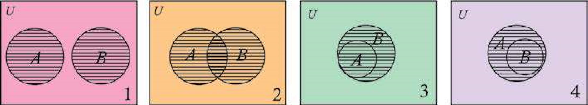

*A*

*+*

*B*

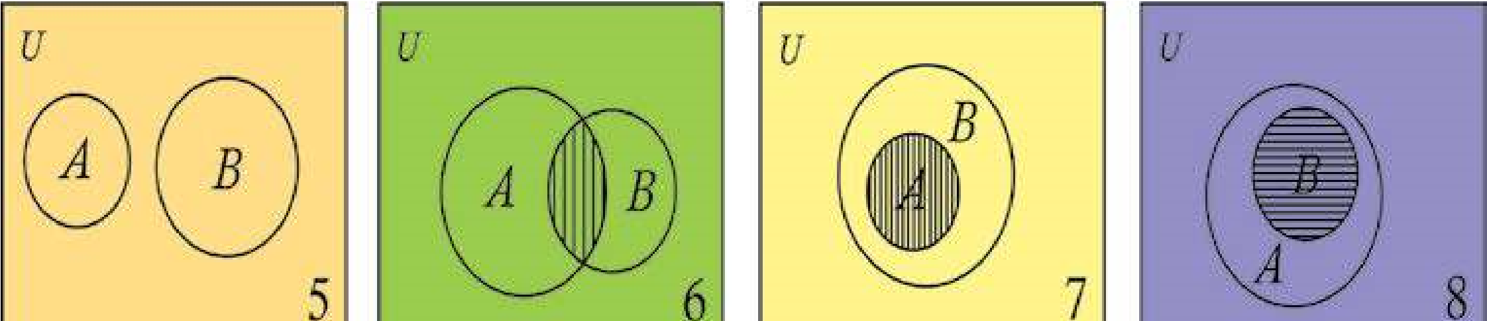

*A*

-

*B*

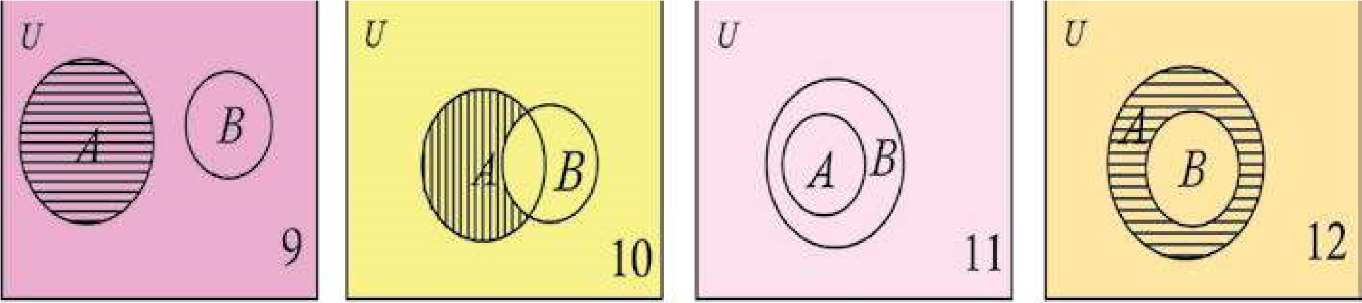

*B*

-

*A*

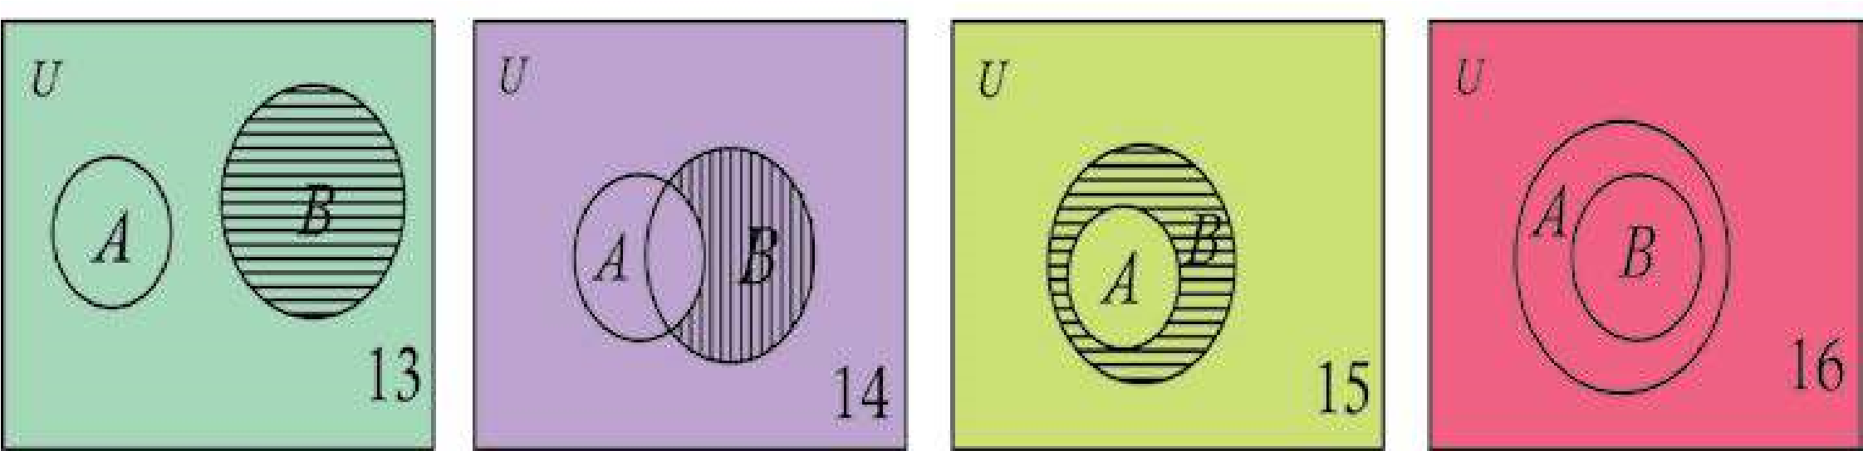

The above diagram suggests the following results: -

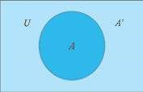

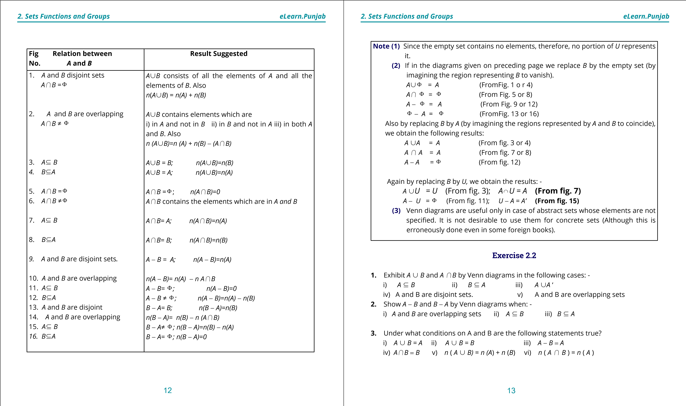

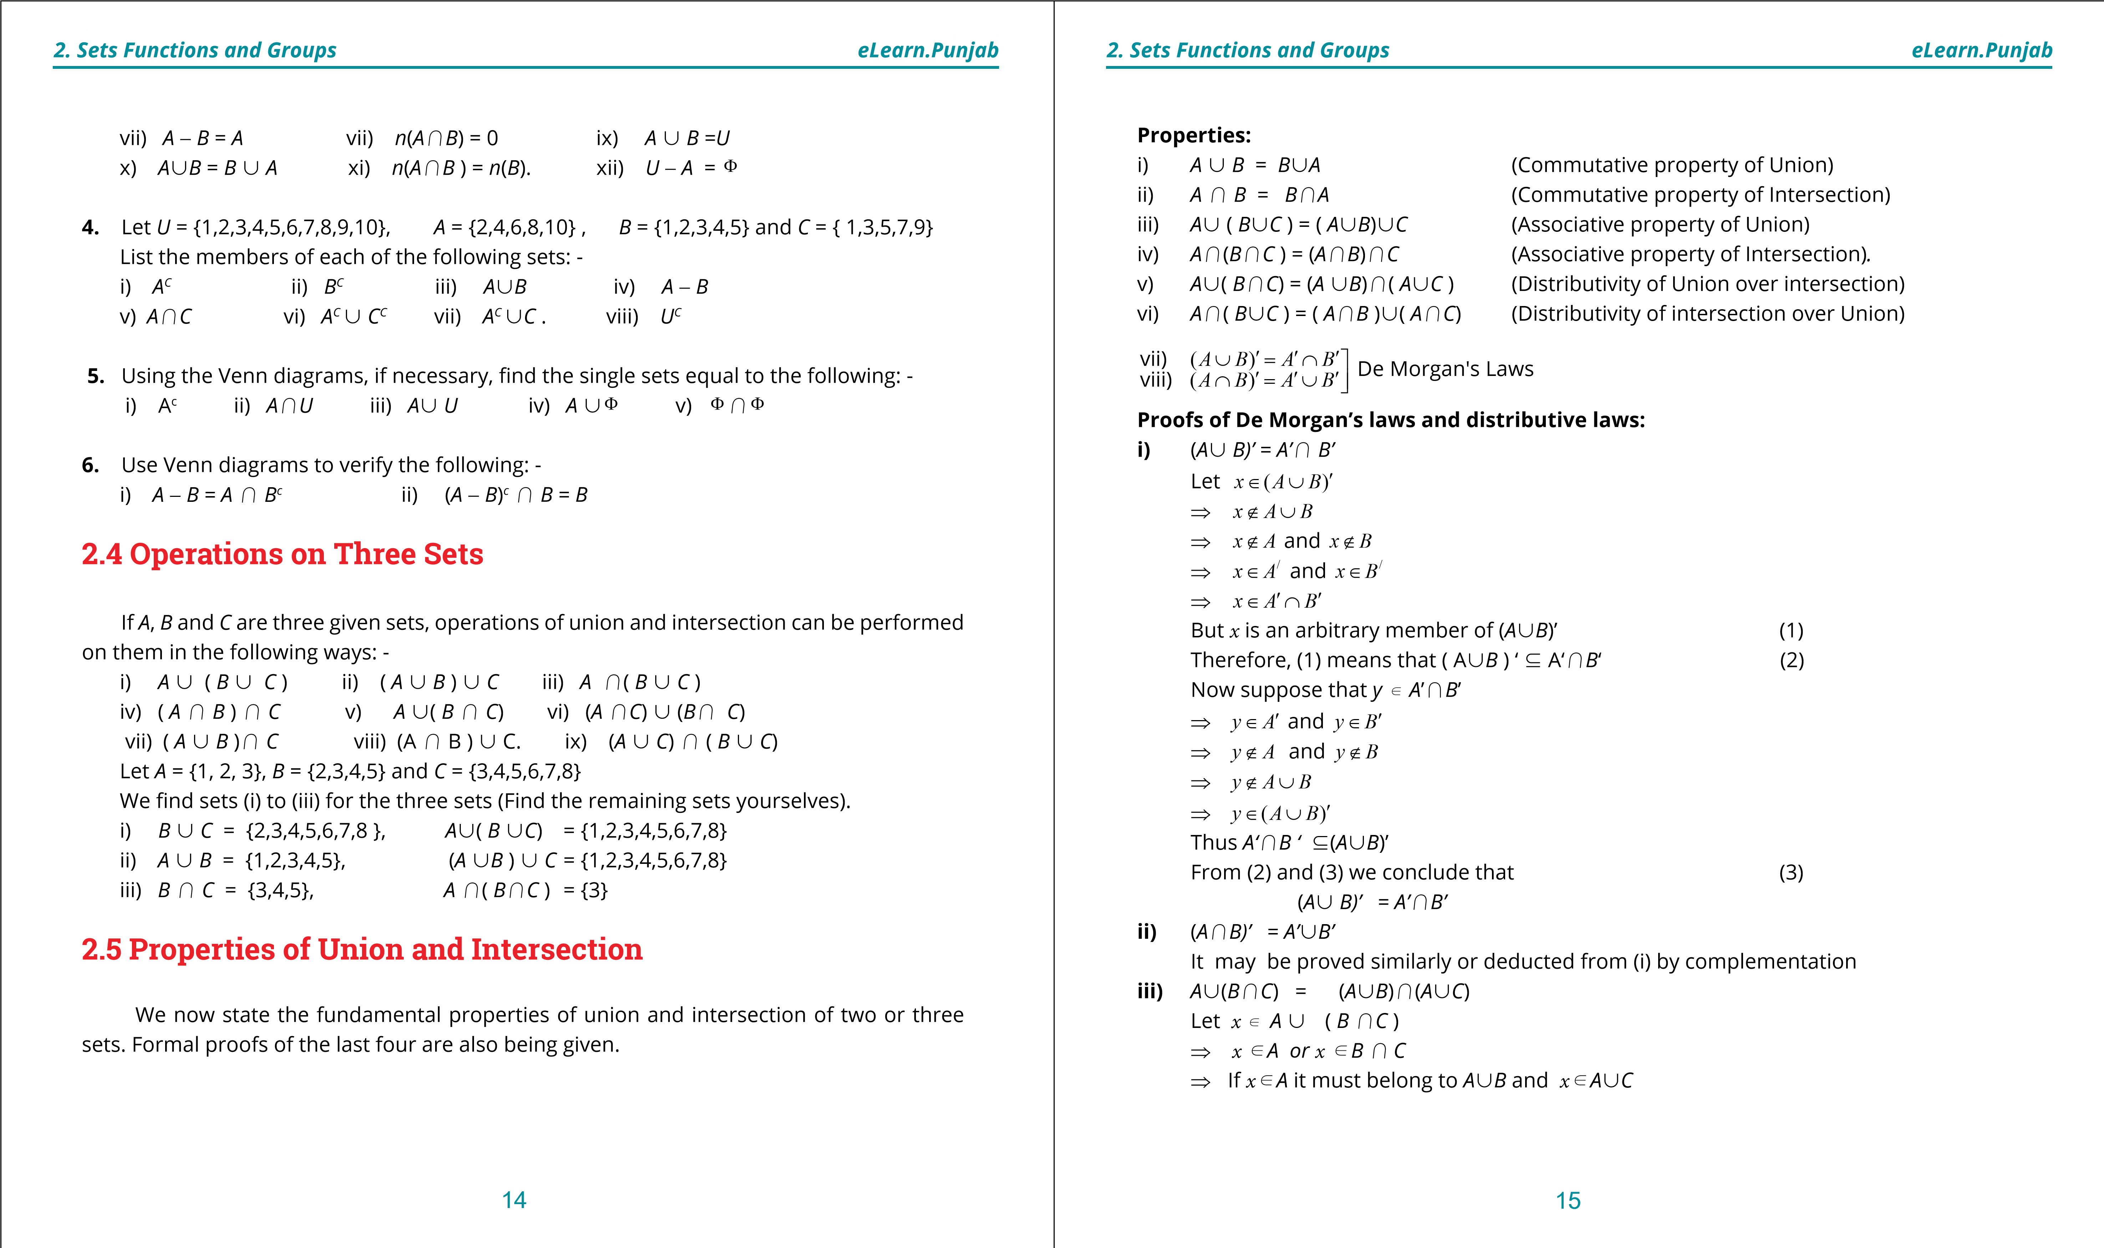

**1. Quadratic Equations eLearn.Punjab 1. Quadratic Equations eLearn.Punjab *2. Sets Functions and Groups eLearn.Punjab 2. Sets Functions and Groups eLearn.Punjab***

⇒ *xd*(*A*~*B*)+(*A*~*C*)

Also if *xdB* +*C* , then *xdB* and *xdC*. (1)

⇒ *xd A*~*B* and *xdA*~*C*

⇒ *xd*(*A*~*B*)*+*(*A*~*C*)

Thus *A*~(*B+C*) 5(*A*~*B*)*+*(*A*~*C*) (2)

Conversely, suppose that *y*∈(*A*∪ *B*)∩(*A*∪*C*)

There are two cases to consider: *y*∈ *A y*, ∉ *A*

In the irst case y U *A* ~(*B+C*) If *y*∉ *A*, it must belong to *B* as well as *C*  i.e., y U (*B*+*C*)

∴ *y*∈ *A*∪(*B* ∩*C*)

So in either case

y*d* ( *A*~*B* ) *+* ( *A*~*C)* L y*dA*~(*B+C*)

thus (*A*∪ *B*) ∩(*A*∪*C*) ⊆ *A*∪(*B* ∩*C*) (3)

From (2) and (3) it follows that *A*~(*B+C* ) = ( *A*~*B* )*+*(*A*~*C*) **iv)** *A* *+*(*B*~*C*) = (*A+B*)~ (*A+C*)

It may be proved similarly or deducted from (iii) by complementation **Verification of the properties:**

**Example 1:** Let *A* = { 1,2,3}, *B* = {2,3,4,5} and *C*= {3,4,5,6,7,8} i) *A*~*B* = {1,2 3} ~ {2,3,4,5} *B*~*A* = {2,3,4,5} ~ {1,2,3} = {1,2,3,4,5} = { 2,3,4,5,1}

∴ *A* ~*B = B* ~*A*

ii) *A+B* = { 1,2,3}*+*{2,3,4,5}  *B+A* = {2,3,4,5} *+* {1,2,3} = {2,3} ={2,3}

∴ *A* + *B = B* + *A* (iii) and (iv) Verify yourselves.

(v) *A*~(*B* *+C*) = {1,2,3 } ~ ({2,3,4,5}*+*{3,4,5,6,7,8)

= {1,2,3 } ~ {3,4,5}

= {1,2,3,4,5} (1)

(*A* ~ *B* )+(*A* ~ *C*) = ({1,2,3}~{2,3,4,5 })*+*({1,2,3}~{3,4,5,6,7,8})

= {1,2,3,4,5} *+* {1,2,3,4,5,6,7,8}

= {1,2,3,4,5} (2)

From (1) and (2),

*A*~( *B +C* ) = (*A* ~ *B* )*+*(*A* ~ *C*)

vi) Verify yourselves. vii) Let the universal set be *U* = { 1,2,3,4,5,6,7,8,9,10}

*A* ~*B* = {1,2,3} ~ {2,3,4,5} = {1,2,3,4,5}

(*A* ~*B* )*’* ={6,7,8,9,10} (1)

*A*’ = *U* - *A* = (4,5,6,7,8,9,10) *B*’ = *U* - *B* = { 1,6,7,8,9,10}

*A*‘ *+B*’ = (4,5,6,7,8,9,10 } *+*{ 1,6,7,8,9,10}

= {6,7,8,9,10} (2)

From (1) and (2),

(*A* ~*B*) ‘ = *A*’ *+B*’

viii) Verify yourselves.

**Veriication of the properties with the help of Venn diagrams.**

**i) and (ii):** Veriication is very simple, therefore, do it *A* yourselves, *B* ~ *C*  **iii):** In ig. (1) set *A* is represented by vertically lined ≡ ∨≡ region and *B* ~ *C* is represented by horizontally lined *A*~(*B* ~ *C*) region. The set *A*~(*B* ~ *C*) is represented by the region |||,≡ ∨ ≡ which is lined either in one or both ways.

≡

≡

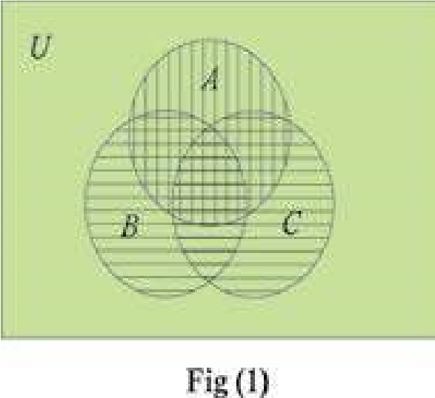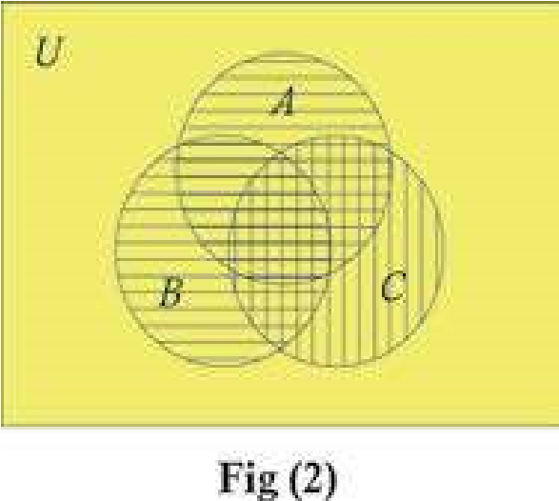

≡

≡

≡

≡

In igure(2) *A* ~*B* is represented by horizontally lined *A* ~*B* region and *C* by vertically lined region. ( *A* ~ *B* ) ~ *C* is C represented by the region which is lined in either one (*A*~*B*)~*C*

or both ways. ≡ ∨≡

16 17

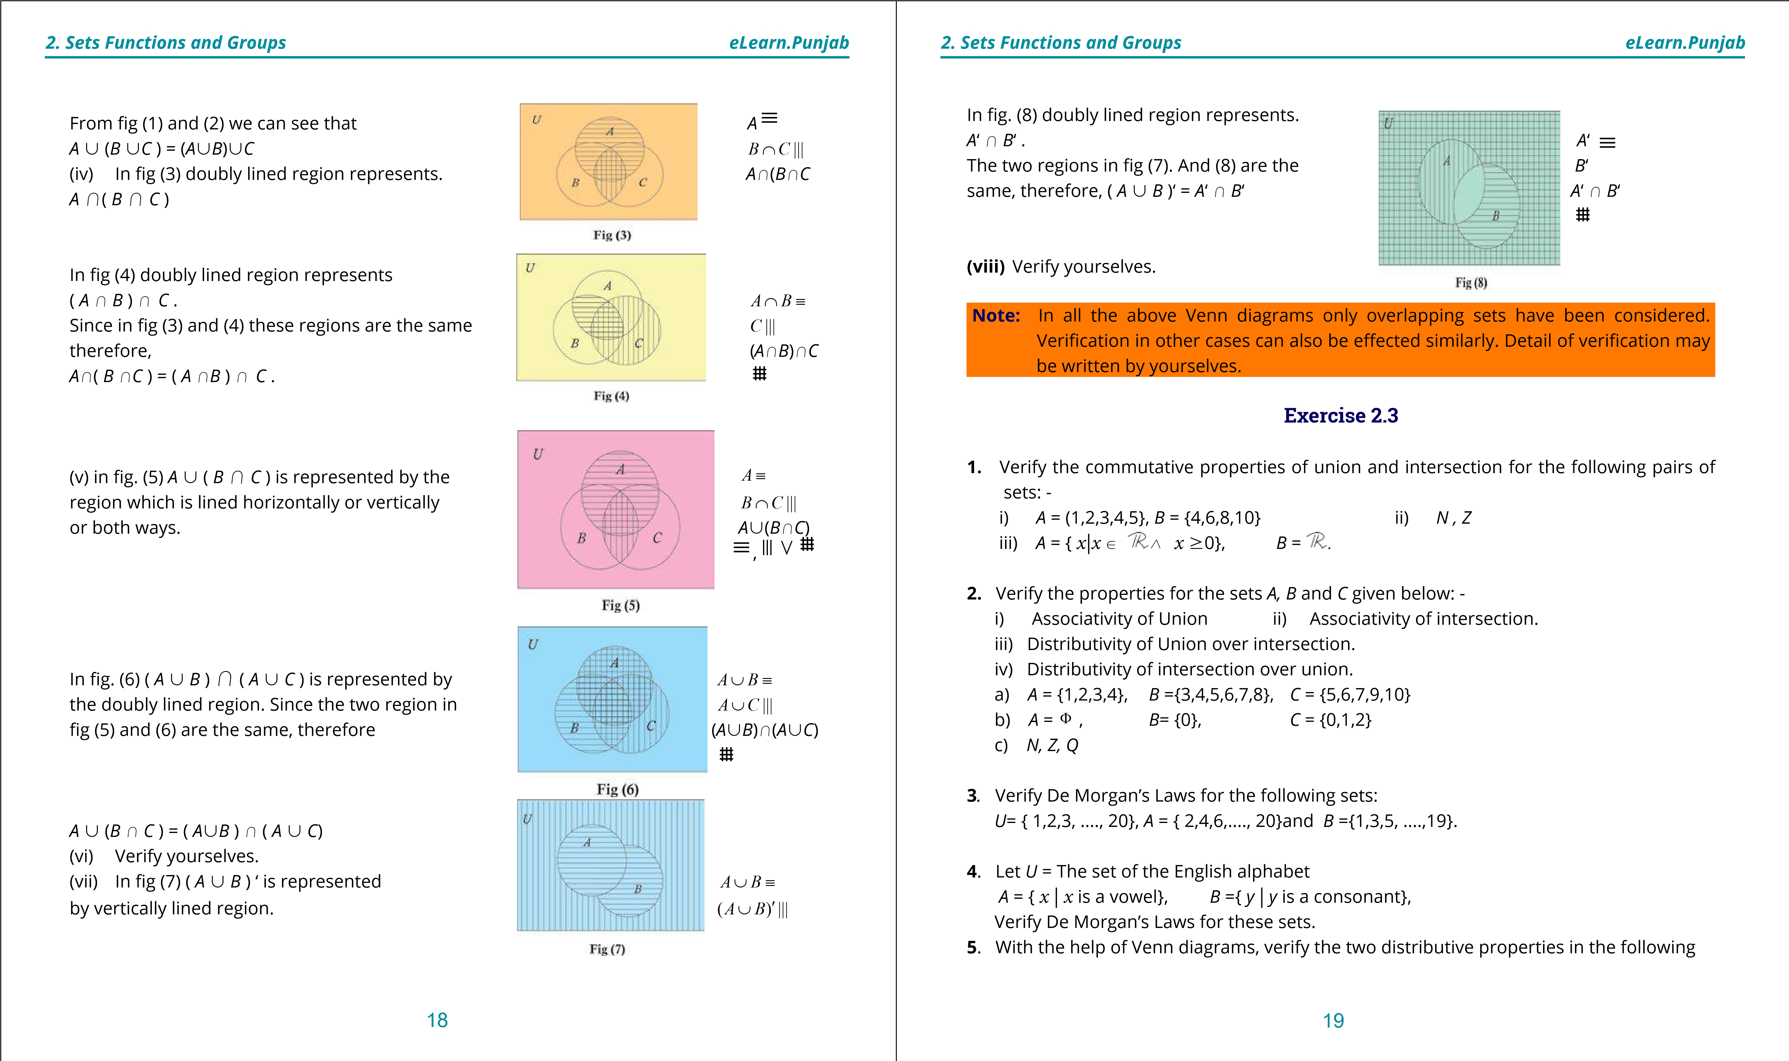

**1. Quadratic Equations eLearn.Punjab 1. Quadratic Equations eLearn.Punjab *2. Sets Functions and Groups eLearn.Punjab 2. Sets Functions and Groups eLearn.Punjab***

cases w.r.t union and intersection.

i) *A* 5 *B*, *A+C* = Φ and *B* and *C* are overlapping. ii) *A* and *B* are overlapping, *B* and *C* are overlapping but *A* and *C* are disjoint.

1. Taking any set, say *A* = {1,2,3,4,5} verify the following: -

i) *A*~Φ =*A* ii) *A*~*A =A* iii) *A+A =A*

1. If *U*= {1,2,3,4,5,...., 20} and *A* = {1,3,5, ...., 19), verify the following:-

i) *A*~*A’ =U*  ii) *A +U = A*  iii)  *A+A’* =Φ

1. From suitable properties of union and intersection deduce the following results:

i) *A+*( *A*~*B*) = *A*~( *A+B* ) ii) *A* ~( *A* *+* *B* ) = *A+*( *A* ~*B*).

1. Using venn diagrams, verify the following results.

i)  *A+B ‘ = A* if A*+B* = Φ ii) (*A* - *B*) ~*B* = *A* ~ *B*. iii) (*A* - *B* ) *+B* = Φ iv) *A*~*B* = *A* ~( *A* ‘*+B*).

**2.6 Inductive and Deductive Logic**

In daily life we often draw general conclusions from a limited number of observations or experiences. A person gets penicillin injection once or twice and experiences reaction soon afterwards. He generalises that he is allergic to penicillin. We generally form opinions about others on the basis of a few contacts only. This way of drawing conclusions is called **induction**.

Inductive reasoning is useful in natural sciences where we have to depend upon repeated experiments or observations. In fact greater part of our knowledge is based on induction.

On many occasions we have to adopt the opposite course. We have to draw conclusions from accepted or well-known facts. We often consult lawyers or doctors on the basis of their good reputation. This way of reasoning i.e., drawing conclusions from premises believed to be true, is called **deduction**. One usual example of deduction is: All men are mortal. We are men. Therefore, we are also mortal.

Deduction is much used in higher mathematics. In teaching elementary mathematics we generally resort to the inductive method. For instance the following sequences can be continued, inductively, to as many terms as we like:

i) 2,4,6,... ii) 1,4,9,... iii) 1,-1,2,-2,3,-3,...

iv) 1,4,7,... v) 1 1, , 1 ,...... vi) 1 , 2 , 4 ,.......

3 12 36 10 100 1000

As already remarked, in higher mathematics we use the deductive method. To start with we accept a few statements (called postulates) as true without proof and draw as many conclusions from them as possible.

Basic principles of deductive logic were laid down by Greek philosopher, Aristotle. The illustrious mathematician Euclid used the deductive method while writing his 13 books of geometry, called Elements. Toward the end of the 17th century the eminent German mathematician, Leibniz, symbolized deduction. Due to this device deductive method became far more useful and easier to apply.

**2.6.1 Aristotelian and non-Aristotelian logics**

For reasoning we have to use *propositions*. A daclarative statement which may be true or false but not both is called a proposition. According to Aristotle there could be only two possibilities - a proposition could be either true or false and there could not be any third possibility. This is correct so far as mathematics and other exact sciences are concerned. For instance, the statement *a = b* can be either true or false. Similarly, any physical or chemical theory can be either true or false. However, in statistical or social sciences it is sometimes not possible to divide all statements into two mutually exclusive classes. Some statements may be, for instance, undecided.

Deductive logic in which every statement is regarded as true or false and there is no other possibility, is called Aristotlian Logic. Logic in which there is scope for a third or fourth possibility is called non-Aristotelian. we shall be concerned at this stage with Aristotelian logic only.

**2.6.2 Symbolic logic**

For the sake of brevity propositions will be denoted by the letters *p , q* etc. We give a

20 21

**1. Quadratic Equations eLearn.Punjab 1. Quadratic Equations eLearn.Punjab *2. Sets Functions and Groups eLearn.Punjab 2. Sets Functions and Groups eLearn.Punjab***

brief list of the other symbols which will be used.

**Symbol How to be read Symbolic expression How to be read**

; not ;*p* Not *p*, negation of *p*

*/* and *p /q p* and *q* ∨ or *p* ∨*q p* or *q*

If *p* then *q*

D If... then, implies *p* D*q p* implies *q*

Is equivalent to, if and *p* if and only if *q*

G only if *p* G*q p* is equivalent to *q*

**Explanation of the use of the Symbols:** *p* ;*p*

1. **Negation:** If *p* is any proposition its negation is denoted by ~*p*, read T F ‘not *p*‘. It follows from this deinition that if p is true, ~*p* is false and if p is false, ~*p* is true. The adjoining table, called truth table, gives the F T

possible truth- values of p and ~*p*. Table (1)

1. **Conjunction** of two statements *p* and *q* is denoted symbolically as *p q* p*/*q  *p/q* (*p* and *q*). A conjunction is considered to be true only if both its components are true. So the truth table of *p* */* *q* is table (2). T T T

**Example 1:** T F F i) Lahore is the capital of the Punjab and F T F

Quetta is the capital of Balochistan.

* 1. 4 < 5*/*8 < 10 F F F
  2. 4 < 5*/*8 > 1 0 Table (2)
  3. 2 + 2 = 3 */*6 + 6 = 10

Clearly conjunctions (i) and (ii) are true whereas (iii) and (iv) are false.

1. **Disjunction** of *p* and *q* is *p* or *q*. It is symbolically written *p* ∨ *q* . *p q p* ∨*q*  The disjunction *p* ∨ *q* is considered to be true when at least one T T T of the components p and q is true. It is false when both of them

are false. Table (3) is the truth table. T F T

F T T

F F F

Table (3)

22

**Example 2:**

**i)** 10 is a positive integer or p is a rational number. Find truth value of this disjunction.

**Solution:** Since the irst component is true, the disjunction is true. **ii)** A triangle can have two right angles or Lahore is the capital of Sind.

**Solution:** Both the components being false, the composite proposition is false.

**2.7 Implication or conditional**

A compound statement of the form if *p* then *q* , also written ***p* implies *q*** , is called a **conditional** or an **implication**, *p* is called the **antecedent** or **hypothesis** and *q* is called the **consequen**t or the **conclusion**.

A conditional is regarded as false only when the antecedent is true and consequent is false. In all other cases it is considered to be true. Its truth table is, therefore, of the adjoining form. *p q p* D *q*

Entries in the irst two rows are quite in consonance with

common sense but the entries of the last two rows seem to be T T T against common sense. According to the third row the conditional T F F

If *p* then *q*

is true when *p* is false and *q* is true and the compound proposition F T T is true (according to the fourth row of the table) even when both its F F T components are false. We attempt to clear the position with the help Table (4)

of an example. Consider the conditional

If a person *A* lives at Lahore, then he lives in Pakistan.

If the antecedent is false i.e., A does not live in Lahore, all the same he may be living in Pakistan. We have no reason to say that he does not live in Pakistan.

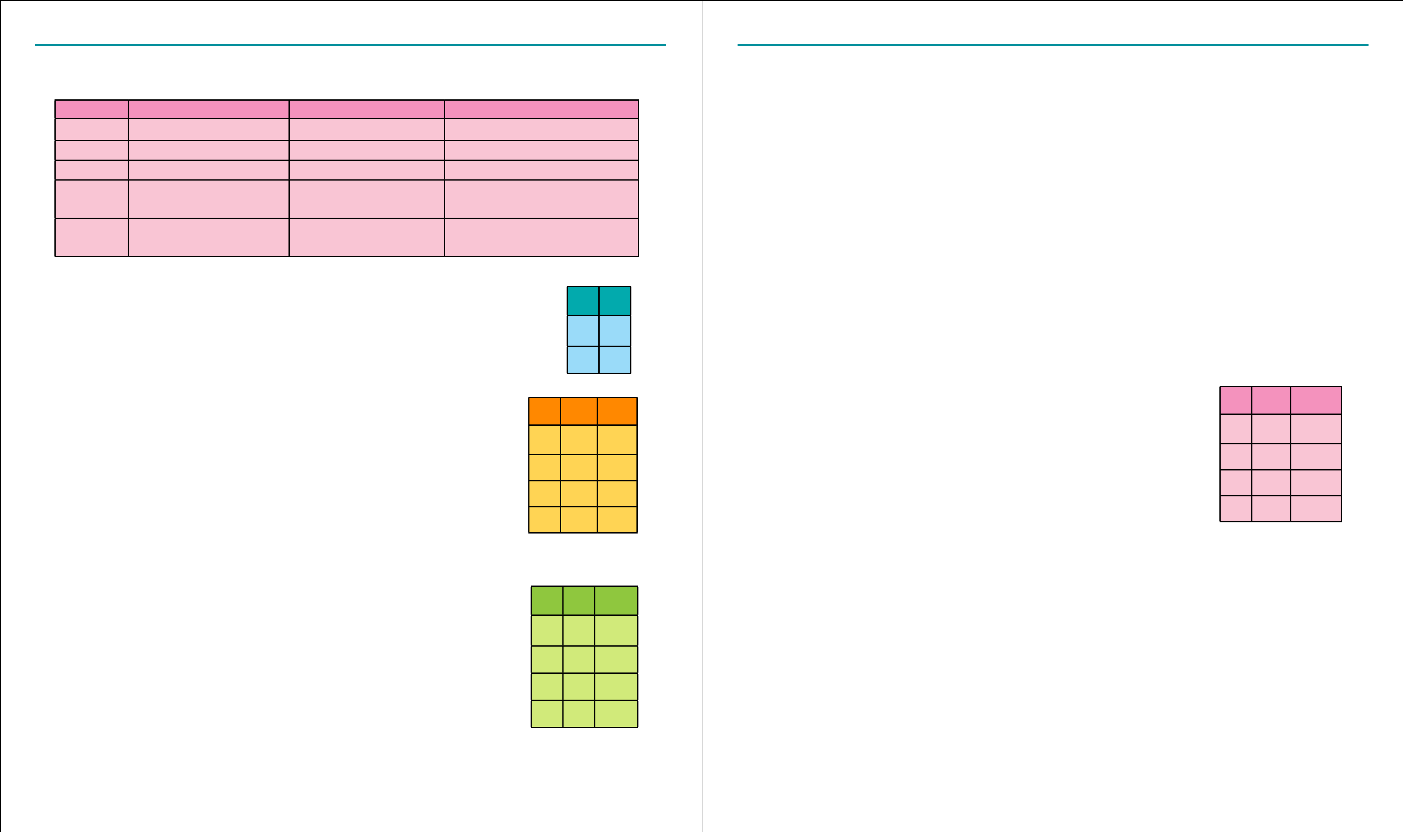We cannot, therefore, say that the conditional is false. So we must regard it as true. It must be remembered that we are discussing a problem of Aristotlian logic in which every proposition must be either true or false and there is no third possibility. In the case under discussion there being no reason to regard the proposition as false, it has to be regarded as true. Similarly, when both the antecedent and consequent of the conditional under consideration are false, there is no justiication for quarrelling with the proposition. Consider another example.

23

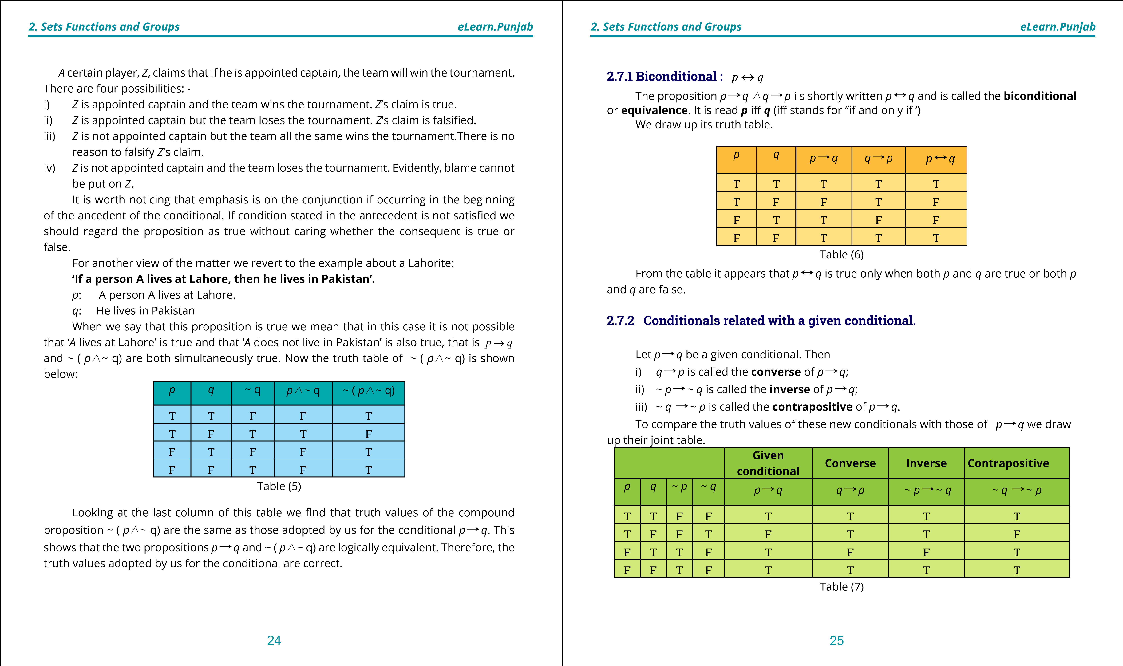

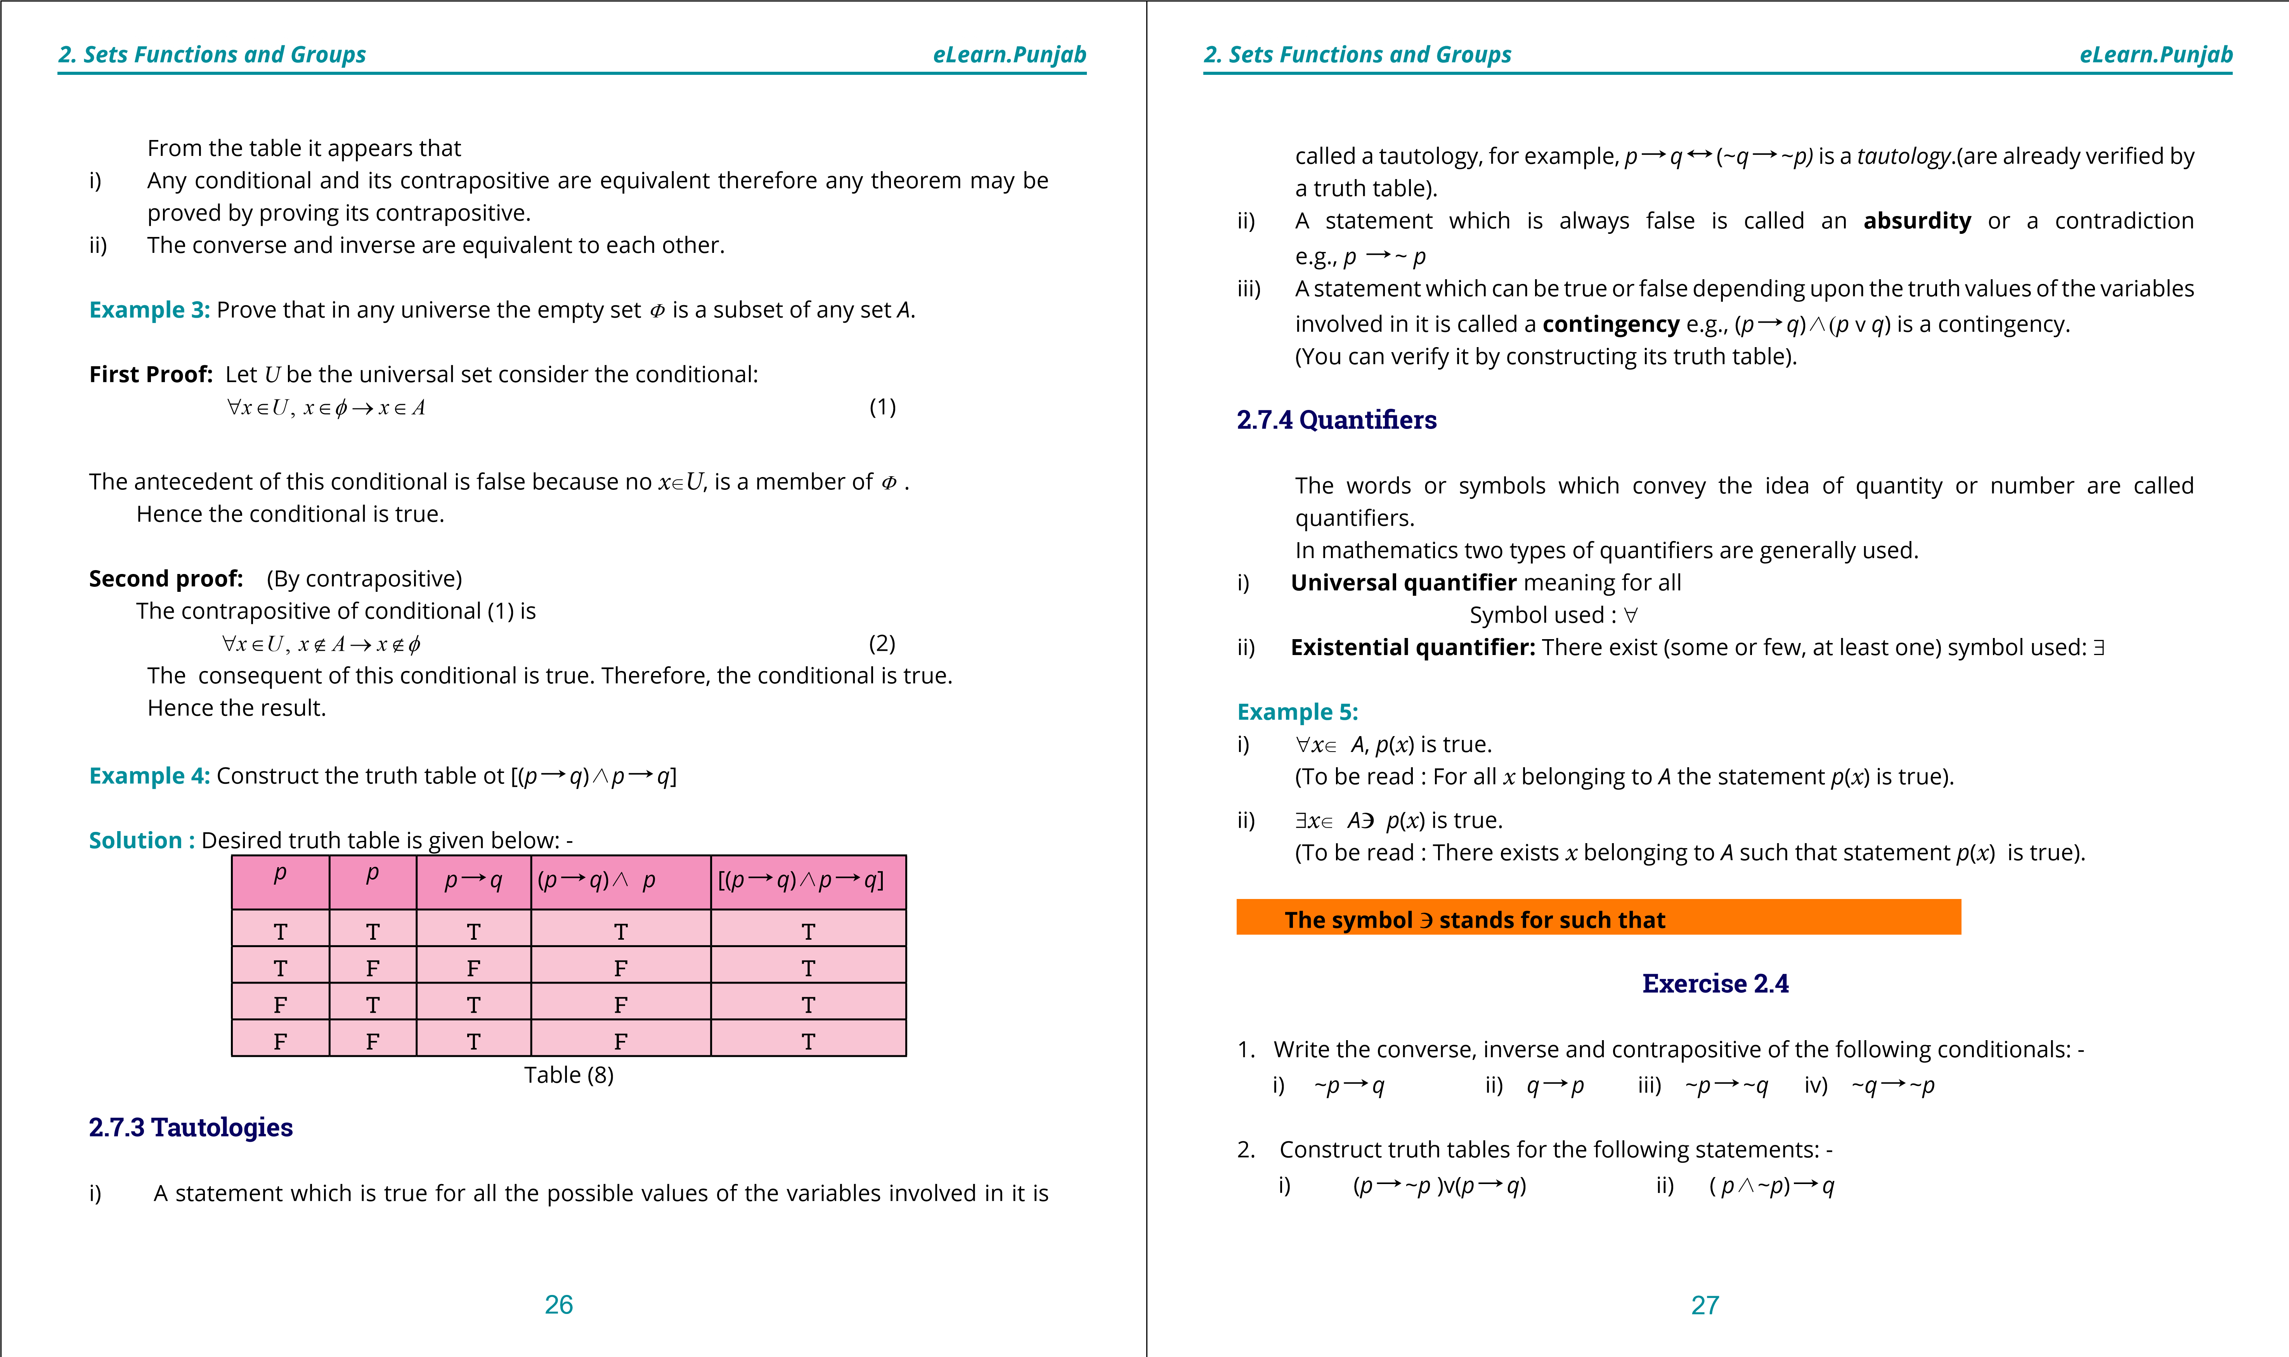

**1. Quadratic Equations eLearn.Punjab 1. Quadratic Equations eLearn.Punjab *2. Sets Functions and Groups eLearn.Punjab 2. Sets Functions and Groups eLearn.Punjab***

iii) ~(*p*D*q*)G(*p/*~*q*)

1. Show that each of the following statements is a tautology: -

i) (*p/q*)D*p* ii) *p*D(*p* v *q*) iii) ~(*p*D*q*) D*p* iv) ~*q/* (*p*D*q*)D~*p*

1. Determine whether each of the following is a tautology, a contingency or an absurdity: -

i) *p/*~*p* ii) *p*D(*q*D*p*) iii) *q* v (~*q* v *p*)

1. Prove that *p* v (~ *p/*~ *q*) v (*p/q*) = *p* v ( ~ *p/*~ *q)*

**2.8** **Truth Sets, A link between Set Theory and Logic.**

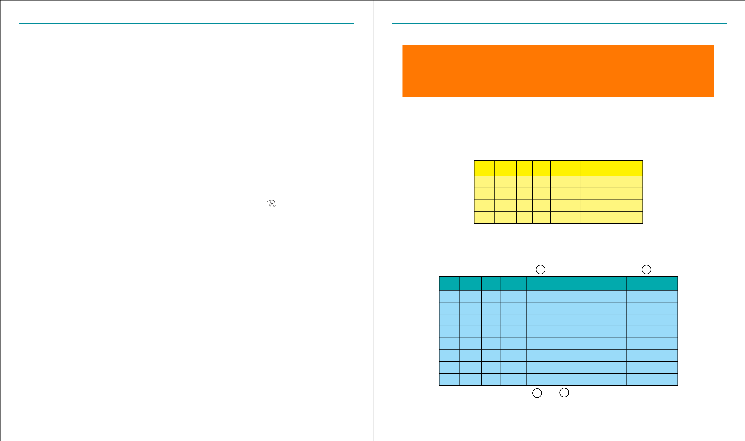Logical propositions *p*, *q* etc., are formulae expressed in terms of some variables. For the sake of simplicity and convenience we may assume that they are all expressed in terms of a single variable *x* where *x* is a real variable. Thus *p* = *p*(*x*) where, *x*U . All those values of *x* which make the formula *p*(*x*) true form a set, say *P*. Then *P* is the truth set of *p*. Similarly, the **truth set**, *Q,* of *q* may be deined. We can extend this notion and apply it in other cases.

1. **Truth set of ~*p*:** Truth set of ~*p* will evidently consist of those values of the variable for which *p* is false i.e., they will be members of *P*’ , the complement of *P*.
2. ***p* v *q*:** Truth set of *p* v *q* = *p*(*x*) v *q*(*x*) consists of those values of the variable for which *p*(*x*) is true or *q*(*x*) is true or both *p*(*x*) and *q*(*x*) are true.

Therefore, truth set of *p* v *q* will be:

*P* ~ *Q* ={ *x*| p(*x*) is true or *q*(*x*) is true} iii) ***p***/***q*:** Truth set of *p*(*x*) / *q*(*x*) will consist of those values of the variable for which both

*p*(*x*) and *q*(*x*) are true. Evidently truth set of *p/q* = *P+Q*

={ *x*| *p*(*x*) is true */q*(*x*) is true}

1. ***p***D***q*:** We know that *p*D*q* is equivalent to ~*p* v *q* therefore truth set of *p*D*q* will be

*P*’~*Q*

1. ***p***G***q*:** We know that *p* G *q* means that *p* and *q* are simultaneously true or false.

Therefore, in this case truth sets of *p* and *q* will be the same i.e.,

*P = Q*

**Note: (1)** Evidently truth set of a tautology is the relevant universal set and that of an absurdity is the empty set Φ.

**(2)** With the help of the above results we can express any logical formula in set- theoretic form and vice versa.

We will illustrate this fact with the help of a solved example.

**Example 1:**  Give logical proofs of the following theorems: -

(*A*, *B* and *C* are any sets)

i) (*A*~*B*)’ = *A*‘*+B*‘ ii) *A+*( *B* ~*C*) = (*A+B*) ~(*A+C*) **Solution:** i) The corresponding formula of logic is

~ (*p* v *q*)=~ *p*/~ *q* (1) We construct truth table of the two sides.

*p p* ~ *p* ~*q p* v *q* ~(*p* v *q*) ~*p* /~*q*

T T F F T F F T F F T T F F F T T F T F F

F F T T F T T

The last two columns of the table establish the equality of the two sides of eq.(1)

(ii) Logical form of the theorem is *p* */* (*q* v *r*) = ( *p* */* *q*) v ( *p/* *r*)

We construct the table for the two sides of this equation

1 2 3 4 5 6 7 8

*p p r q* v *r p/*(*q* v *r*) *p/q p/r (p/q)* v *(p/r)*

T T T T T T T T T T F T T T F T T F T T T F T T

T F F F F F F F

F T T T F F F F F T F T F F F F

F F T T F F F F

F F F F F F F F

Comparison of the entries of columns and is suicient to establish the desired result.5 8

28 29

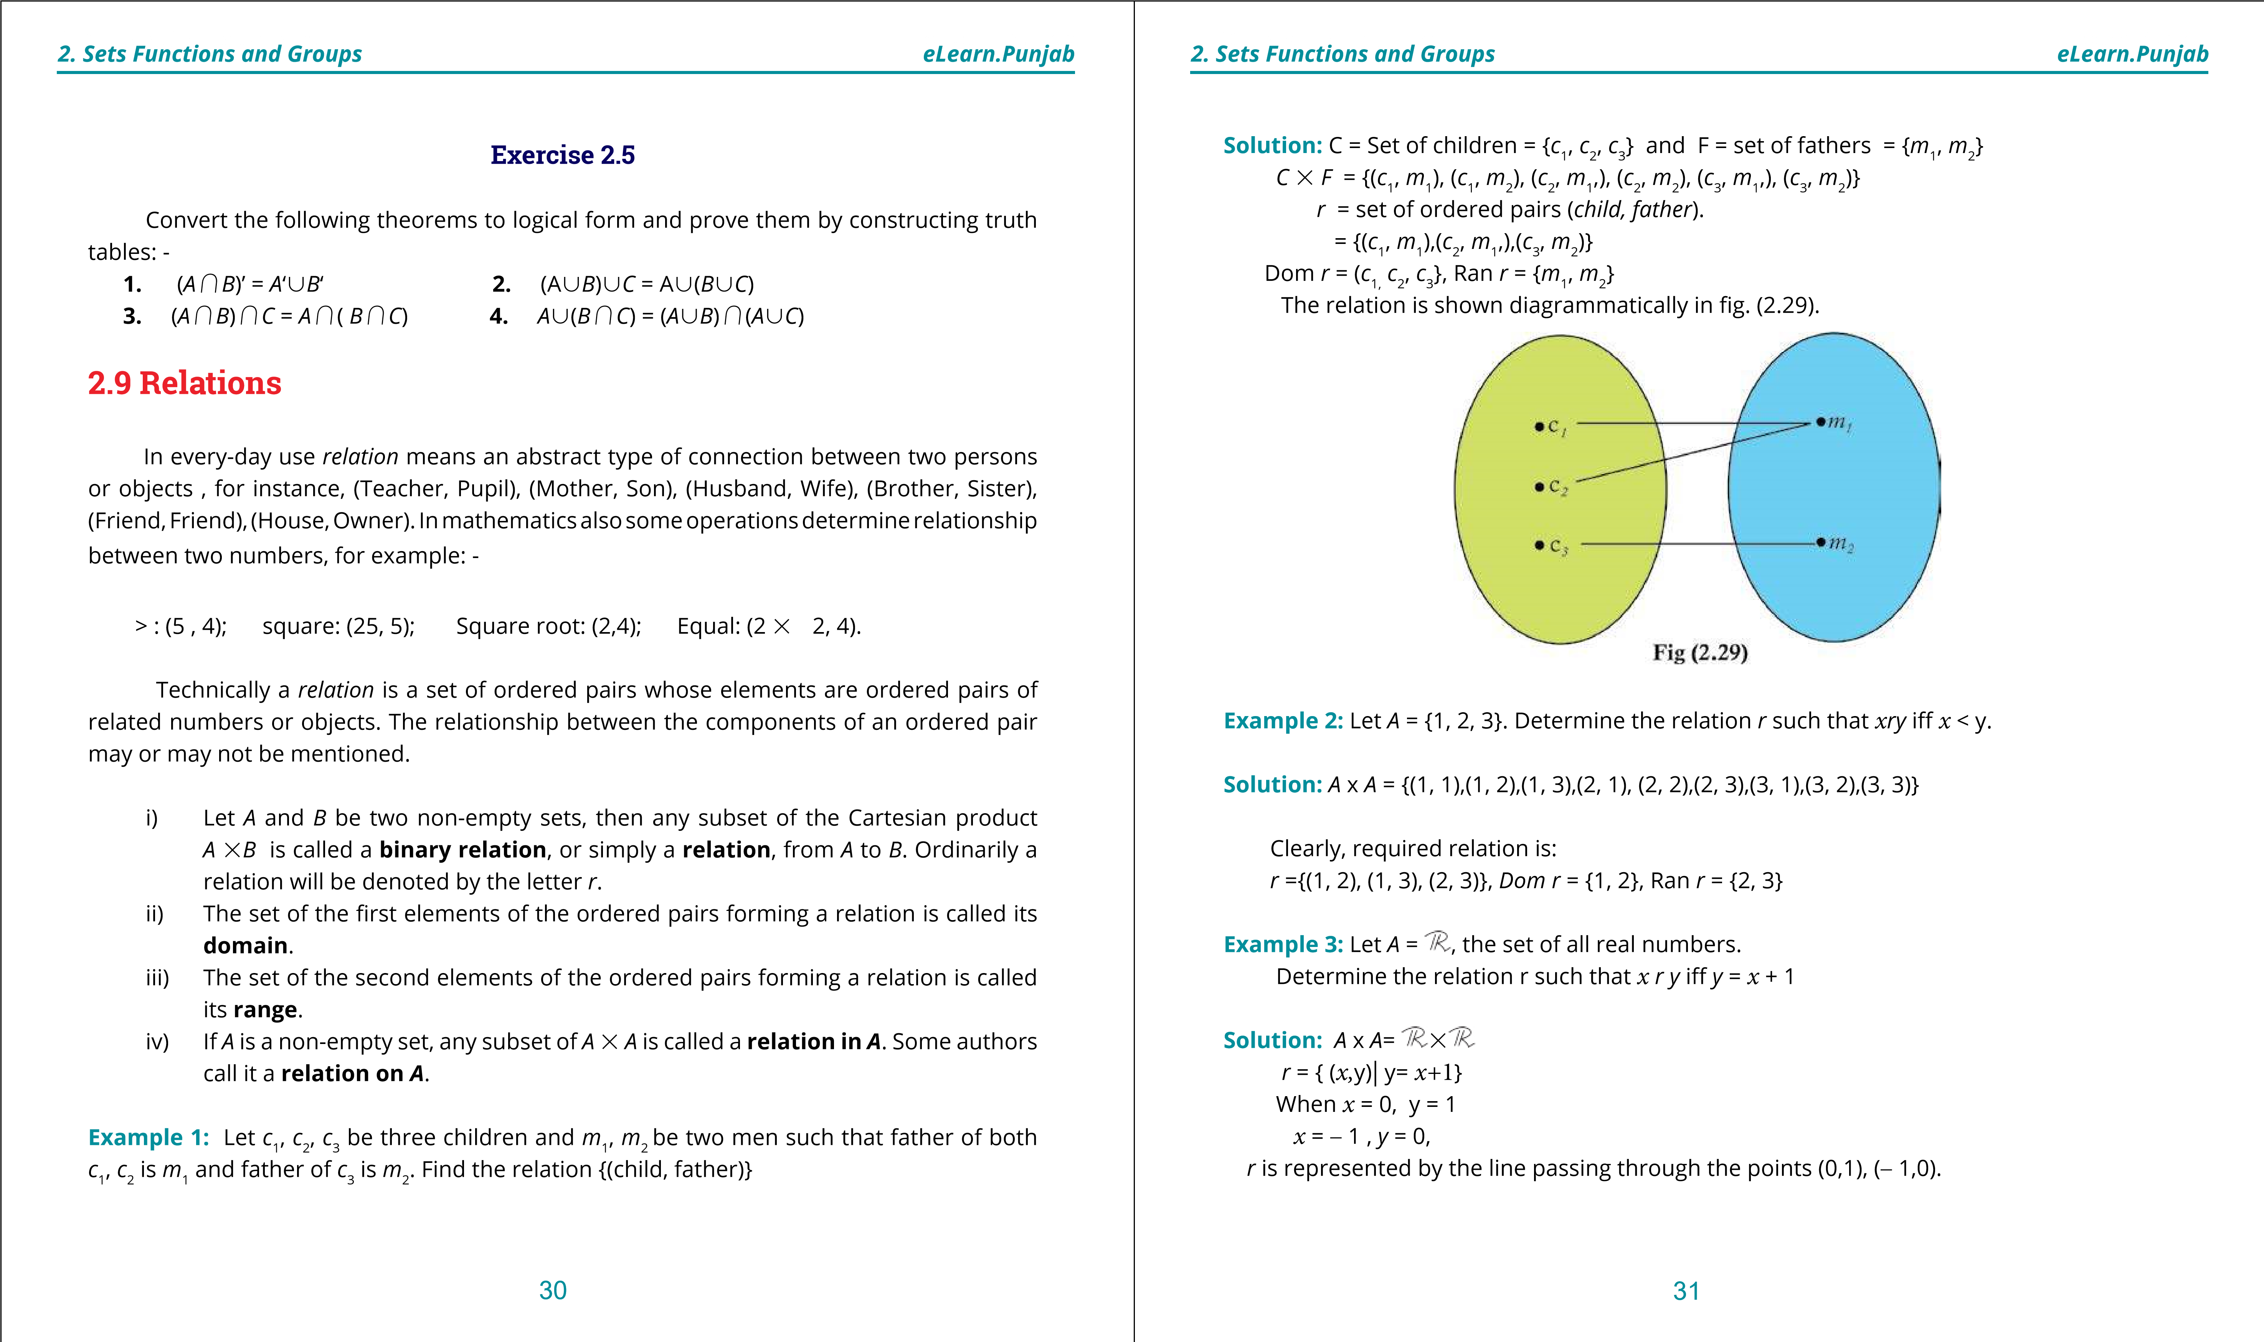

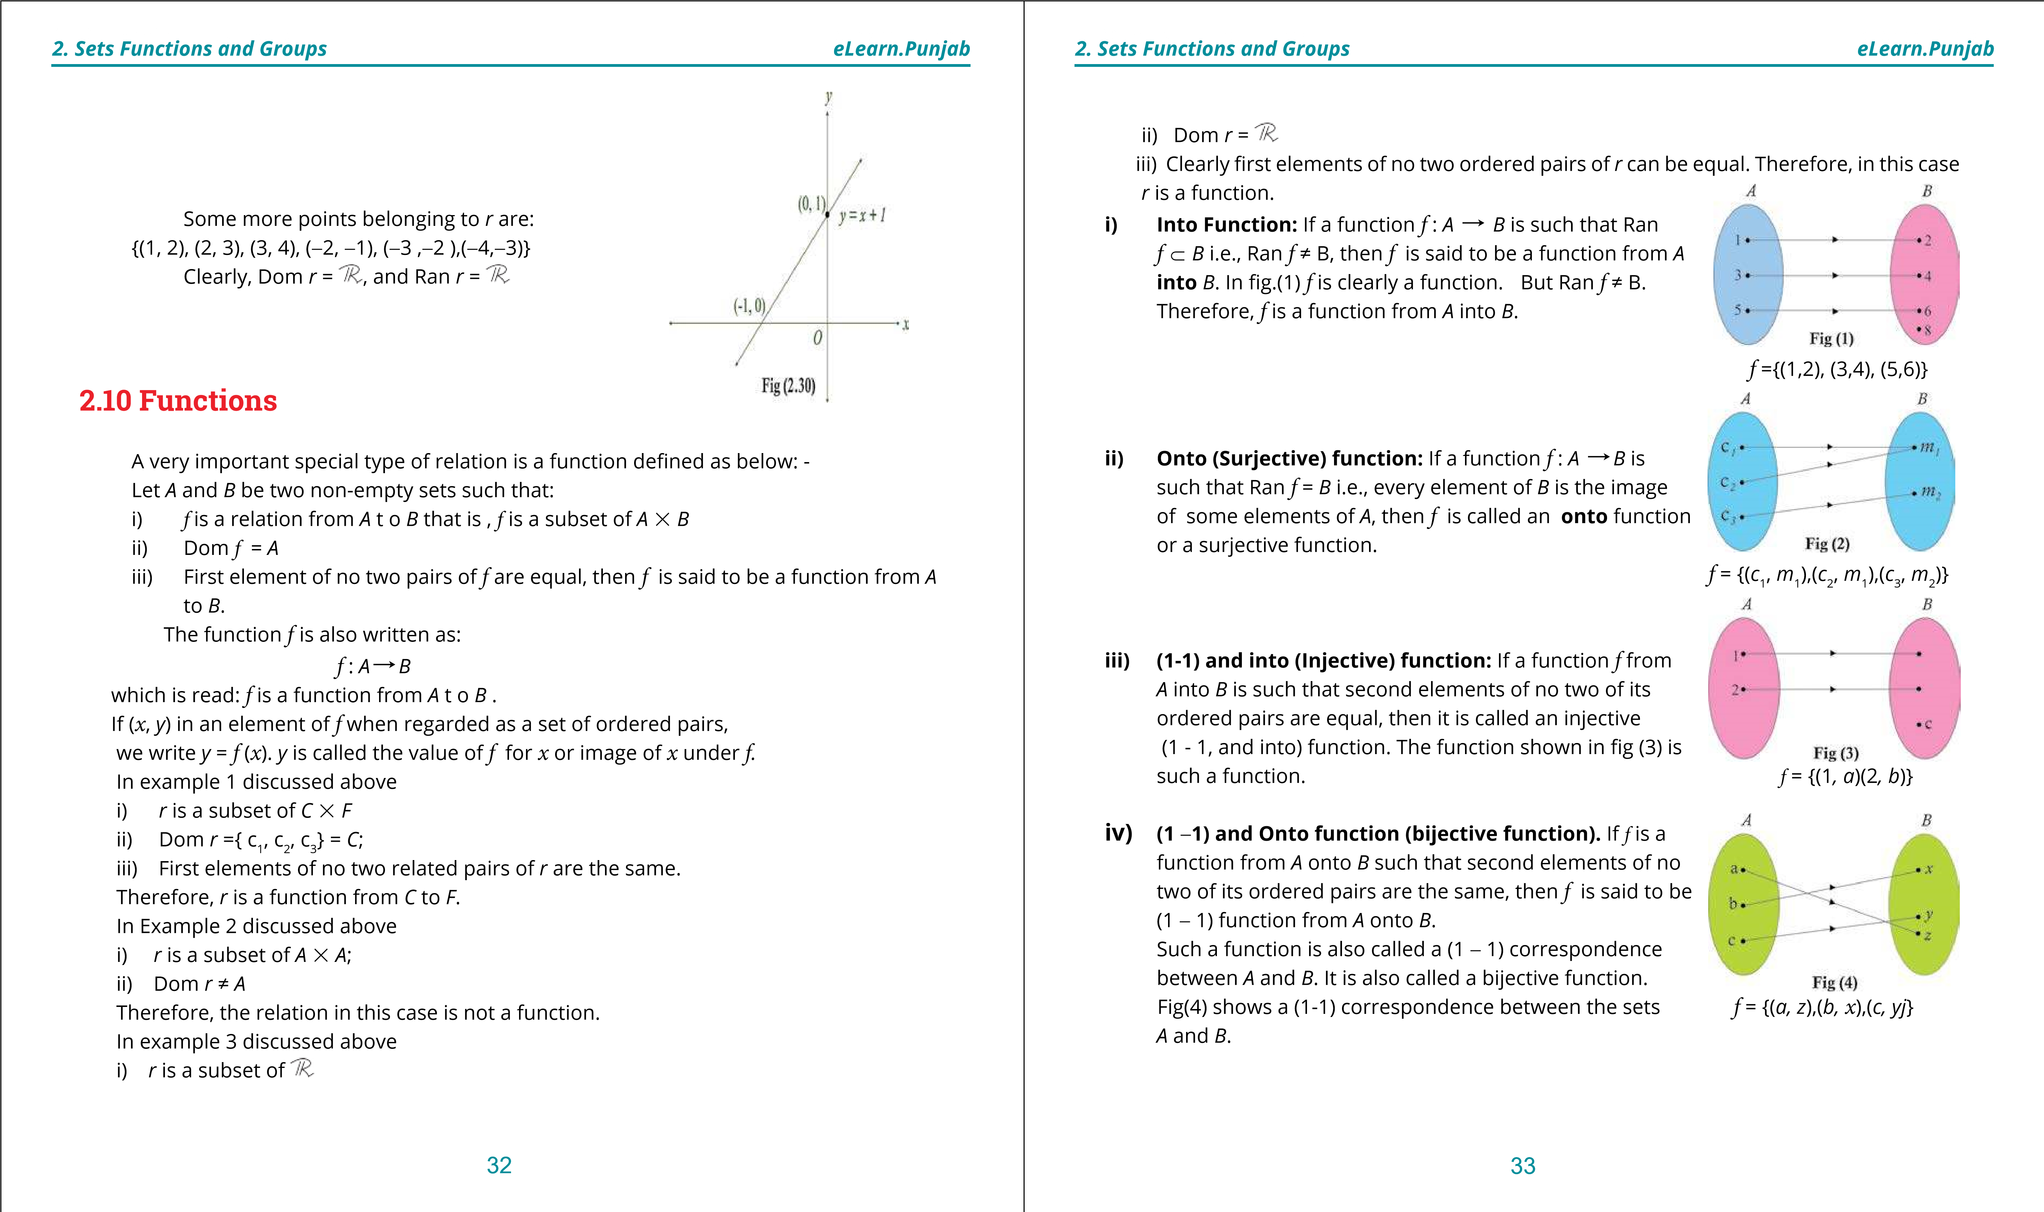

**1. Quadratic Equations eLearn.Punjab 1. Quadratic Equations eLearn.Punjab *2. Sets Functions and Groups eLearn.Punjab 2. Sets Functions and Groups eLearn.Punjab***

(*a, z*), (*b, x)* and (*c, y*) are the pairs of corresponding elements i.e., in this case *f* = {(*a, z*), (*b, x*), (*c, y*)} which is a bijective function or (1 - 1) correspondence between the sets *A* and *B*.

**Set - Builder Notation for a function:** We know that set-builder notation is more suitable for ininite sets. So is the case in respect of a function

comprising ininite number of ordered pairs. Consider for instance, the function *f* = { (1,1), (2,4), (3, 9), (4, 16),...} Dom *f* = (1, 2, 3,4, ...}.and Ran *f* = {1,4,9, 16, ...} This function may be written as: *f* = {(*x,* y) | *y* =*x*2*, x dN* } For the sake of brevity this function may be written as:  *f* = function deined by the equation *y*= *x*2 *, x dN*

Or, to be still more brief: The function *x*2 *, x dN*

In algebra and Calculus the domain of most functions is and if evident from the context it is, generally, omitted.

**2.10.1 Linear and Quadratic Functions**

The function {(*x y*, )| *y* = *mx* + *c*} is called a **linear function**, because its graph (geometric representation) is a straight line. Detailed study of a straight line will be undertaken in the next class. For the present it is suicient to know that an equationof the form  *y = mx + c* or *ax* + *by* + *c* = 0 represents a straight line . This can be easily veriied by drawing graphs of a few linear equations with numerical coeicients. The function {(*x*, *y*)|y = *ax*2 + b*x* + c} is called a **quadratic function** because it is deined by a quadratic (second degree) equation in *x*, y.



1

2

2

3

1

2

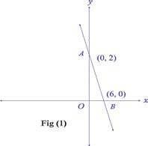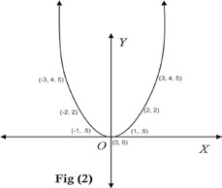

**Example 4:** Give rough sketch of the functions

i) {(*x y*, ) 3*x* + *y* = 2} ii) {(*x y*, ) y = *x*2}

**Solution:**

i) The equation deining the function is 3*x* + *y* = 2

⇒ *y* = -3*x* + 2

We know that this equation, being linear, represents a straight line. Therefore, for drawing its sketch or graph only two of its points are suicient.

When *x* = 0, *y* = 2,

When *y* = 0, *x* = = 0.6 nearly. So two points on the line

are *A* (0, 2) and *B* = (0.6, 0).

Joining *A* and *B* and producing *AB* in both directions, we obtain the line *AB* i.e., graph of the given function. ii) The equation deining the function is y= *x2*.

Corresponding to the values 0, ± 1, ±2, ±3 ... of *x*, values of *y* are 0, .5, 2, 4.5, ...

We plot the points (0, 0), (!1, .5), (!2, 2), (!3, 4.5), ... Joining them by means of a smooth curve and extending it upwards we get the required graph. We notice that: i) The entire graph lies above the *x*-axis.

ii) Two equal and opposite values of *x* correspond to every value of *y* (but not vice versa). iii) As *x* increases (numerically) *y* increases and there is no end to their ncrease. Thus the graph goes ininitely upwards. Such a curve is called a parabola. The students will learn more about it in the next class.

**2.11 Inverse of a function**

If a relation or a function is given in the tabular form i.e., as a set of ordered pairs, its inverse is obtained by interchanging the components of each ordered pair. The inverse of *r* and *f* are denoted *r* -1 and *f* -1 respectively.

If *r* or *f* are given in set-builder notation the inverse of each is obtained by interchanging *x* and *y* in the deining equation. The inverse of a function may or may not be a function.

The inverse of the linear function

{(*x*, *y*) | y = *mx* + *c*} is {(*x*, *y*) | *x* = *my* + *c*} which is also a linear function. Briely, we may say that the **inverse of a line is a line.**

34 35

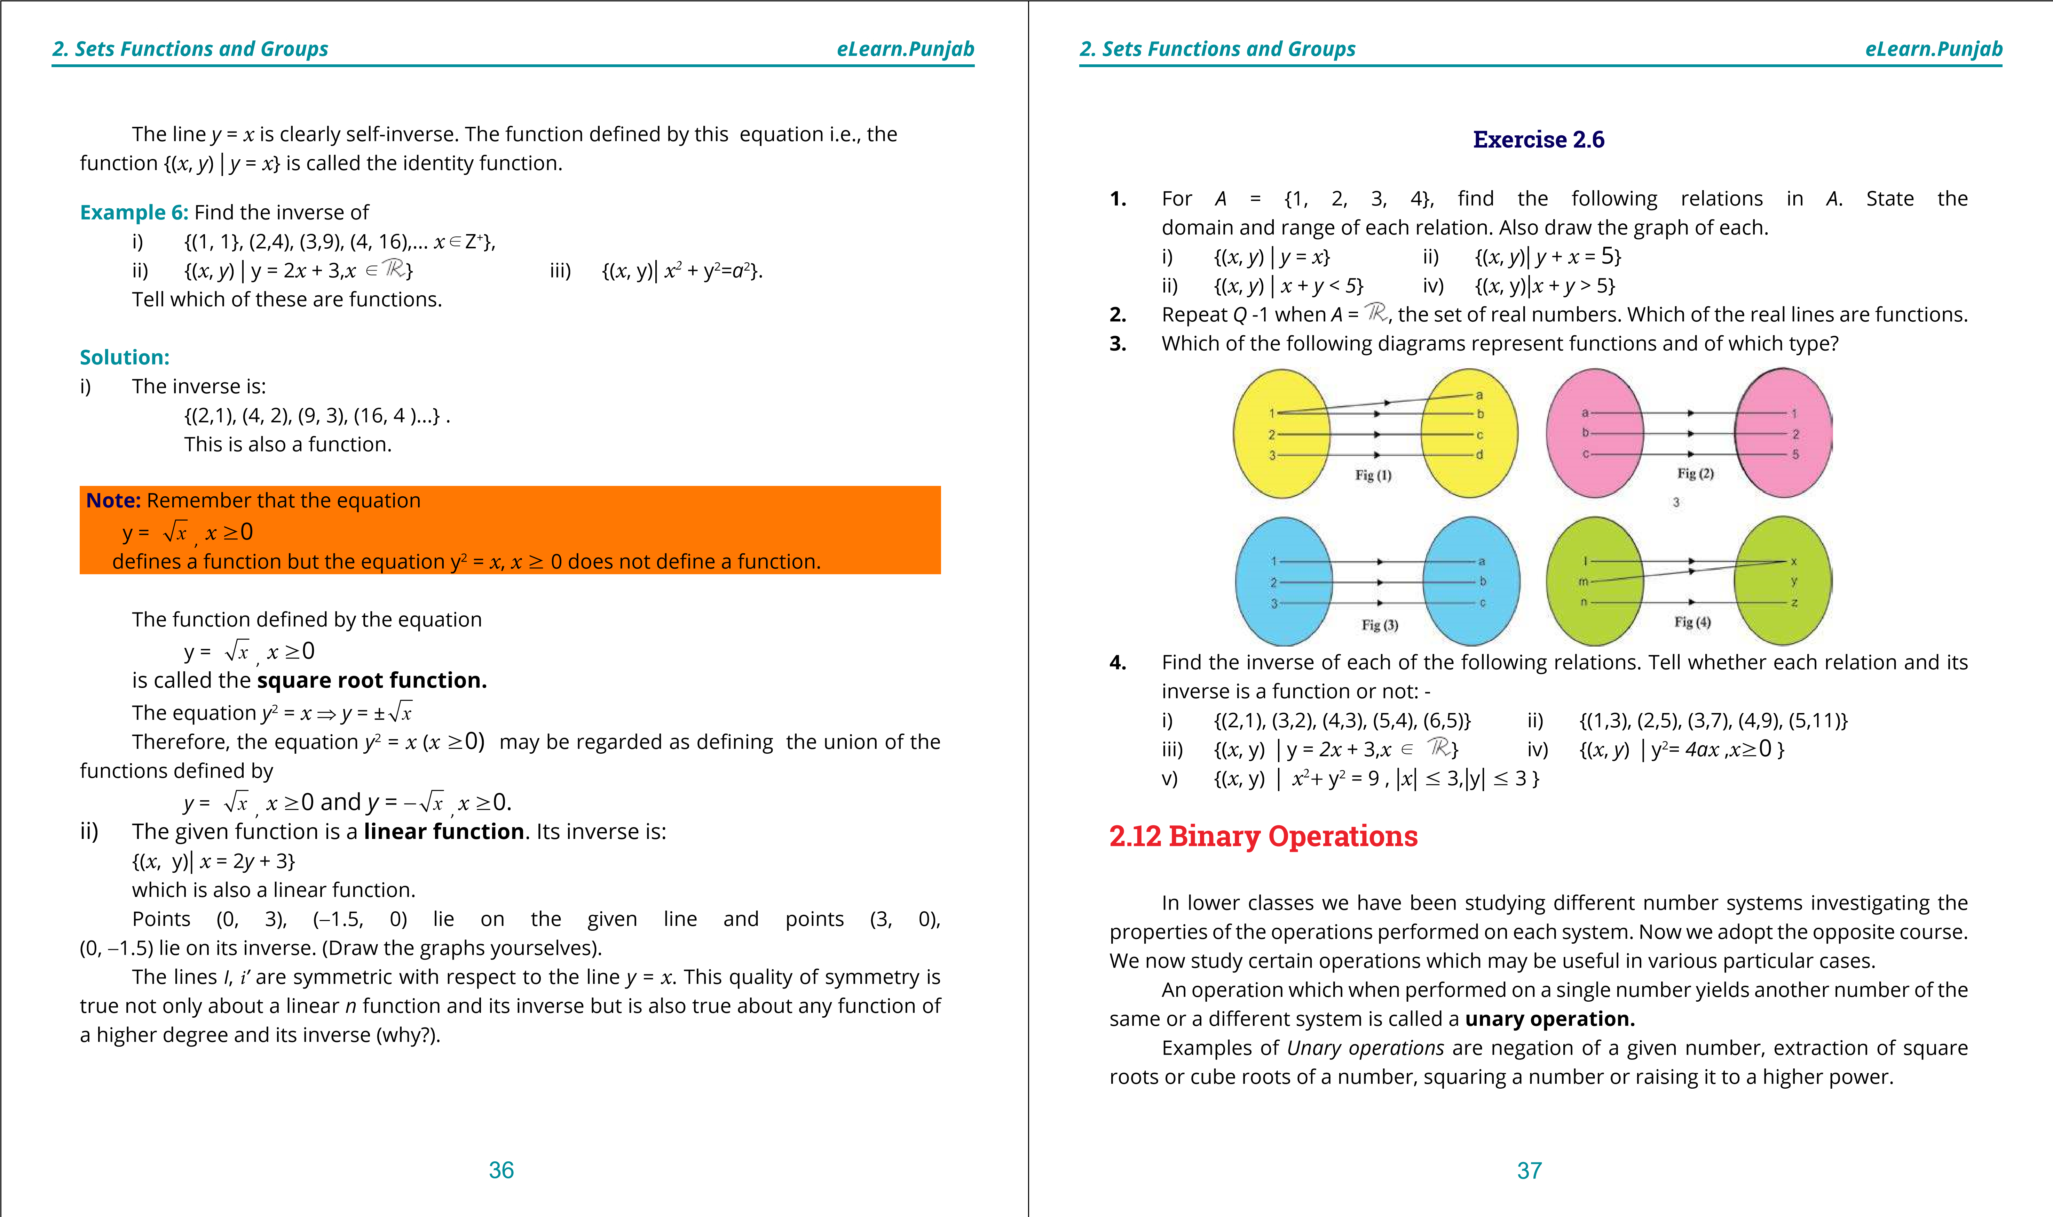

**1. Quadratic Equations eLearn.Punjab 1. Quadratic Equations eLearn.Punjab *2. Sets Functions and Groups eLearn.Punjab 2. Sets Functions and Groups eLearn.Punjab***

We now consider binary operation, of much greater importance, operation which requires two numbers. We start by giving a formal deinition of such an operation. A *binary operation* denoted as %.... (read as star) on a non-empty set *G* is a function which associates with each ordered pair (*a, b*), of elements of *G*, a unique element, denoted as a%.... *b* of *G*.

In other words, a binary operation on a set *G* is a function from the set *G* % *G* to the set *G*. For convenience we often omit the word *binary* before *operation*.

Also in place of saying%.... is an operation on *G*, we shall say *G* is closed with respect to%.... . **Example 1:** Ordinary addition, multiplication are operations on *N*. i.e., *N* is closed with respect to ordinary addition and multiplication because

" *a ,bd N* , *a + b* *d N* */ a. b* *d N*

("stands for” for all” and */* stands for” and”)

**Example 2:** Ordinary addition and multiplication are operations on *E*, the set of all even natural numbers. It is worth noting that addition is not an operation on *O*, the set of old natural numbers.

**Example 3:** With obvious modiication of the meanings of the symbols, let *E* be any even natural number and *O* be any odd natural number, then + *E* *O*  *E* + *E* = *E* (Sum of two even numbers is an even number). *E E* *O*

*E* +*O* = *O*

and *O*+*O* = *E* *O* *O E*

These results can be beautifully shown in the form of a table given above:

This shows that the set {*E*, *O*} is closed under (ordinary) addition.

The table may be read (horizontally).

*E*+ *E* = *E,* *E* + *O = O;*

*O*+*O* = *E,* *O* + *E* = *O*

* 1 -1 *i* - *i*

**Example 4:** The set (1 ,-1*, i*, -*i* } where *i =* -1is closed 1 1 -1 *i* - *i* w.r.t multiplication (but not *w. r. t* addition). This -1 -1 1 - *i i*

can be veriied from the adjoining table.

*i i* - *i* -1 1

* *i* - *i i* 1 -1

**Note:** The elements of the set of this example are the **fourth roots** of unity.

**Example 5:** It can be easily veriied that ordinary -1 11 ww ww22 multiplication (but not addition) is an operation on the

set {1,w,w2} where w3 =1. The adjoining table may be used w w w2 1for the veriication of this fact. w2 w2 1w

(w is pronounced omega)

**Operations on Residue Classes Modulo *n*.**

Three consecutive natural numbers may be written in the form:

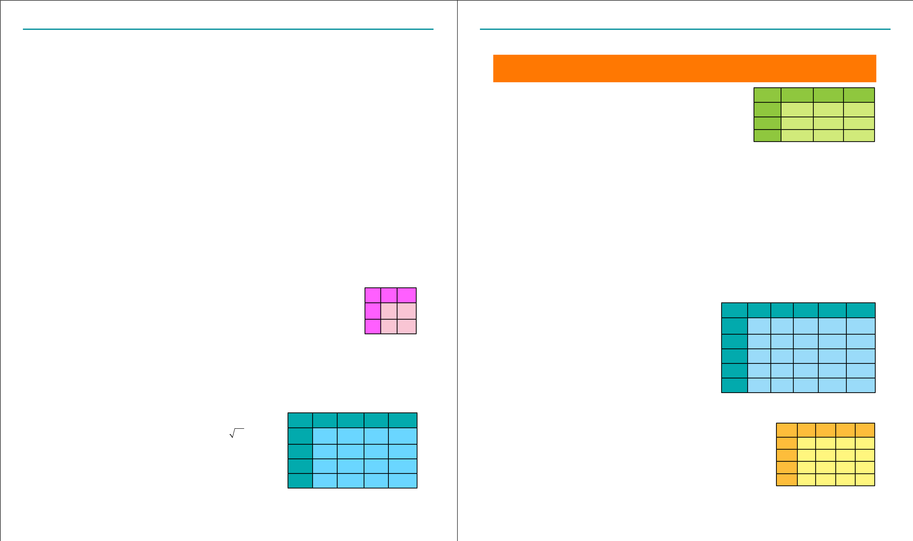 3*n*, 3*n* +1, 3*n* + 2 When divided by 3 they give remainders 0, 1, 2 respectively. Any other number, when divided by 3, will leave one of the above numbers as the reminder. On account of their special importance (in theory of numbers) the remainders like the above are called **residue classes Modulo 3.** Similarly, we can deine **Residue classes Modulo 5** etc. An interesting fact about residue classes is that ordinary addition and multiplication are operations on such a class.

**Example 6:** Give the table for addition of elements of the set of residue classes modulo 5.

**Solution:** Clearly {0,1,2,3,4} is the set of residues that + 0 1 2 3 4 we have to consider. We add pairs of elements as in 0 0 1 2 3 4

ordinary addition except that when the sum equals

1 1 2 3 4 0 or exceeds 5, we divide it out by 5 and insert the

remainder only in the table. Thus 4 + 3 = 7 but in 2 2 3 4 0 1 place of 7 we insert 2(= 7#5) in the table and in place 3 3 4 0 1 2 of 2 + 3 = 5 , we insert 0(= 5#5). 4 4 0 1 2 3

**Example 7:** Give the table for addition of elements of the set of residue classes modulo 4.

**Solution:** Clearly {0,1,2,3}is the set of residues that we have to + 0 1 2 3

0 0 1 2 3

*c*onsider. We add pairs of elements as in ordinary addition except 1 1 2 3 0

that when the sum equals or exceeds 4, we divide it out by 4 and 2 2 3 0 1

insert the remainder only in the table. Thus 3 + 2 = 5 but in place 3 3 0 1 2

381. Quadratic Equations eLearn.Punjab 1. Quadratic Equations eLearn.Punjab 2. Sets Functions and Groups eLearn.Punjab 2. Sets Functions and Groups eLearn.Punjab 39

of 5 we insert 1( = 5#4 ) in the table and in place of 1 + 3 = 4 , we insert 0(= 4#4).

**Example 8:** Give the table for multiplication of elemnts of the set of residue classes modulo 4.

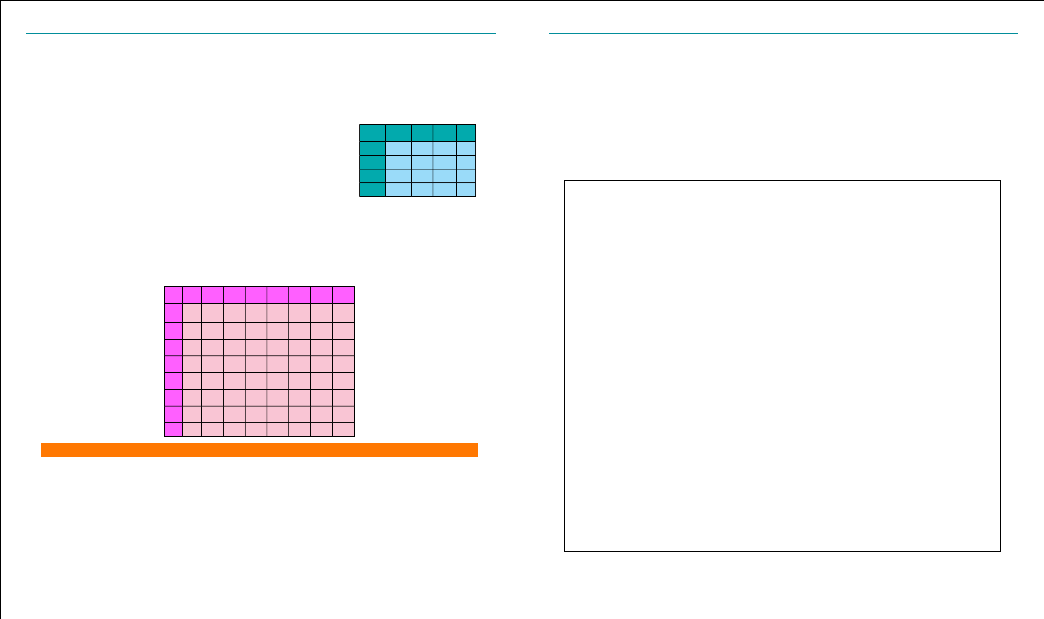**Solution:** Clearly {0,1,2,3} is the set of residues that we have to - 0 1 2 3 consider. We multiply pairs of elements as in ordinary 0 0 0 0 0 multiplcation except that when the product equals or exceeds 4, 1 0 1 2 3 we divide it out by 4 and insert the remainder only in the table. 2 0 2 0 2 Thus 3%2=6 but in place of 6 we insert 2 (= 6#4 )in the table and 3 0 3 2 1 in place of 2%2=4, we insert 0(= 4#4).

**Example 9:** Give the table for multiplication of elements of the set of residue classes modulo 8.

**Solution:** Table is given below:

- 0 1 2 3 4 5 6 7

1. 0 0 0 0 0 0 0 0
2. 0 1 2 3 4 5 6 7
3. 0 2 4 6 0 2 4 6
4. 0 3 6 1 4 7 2 5
5. 0 4 0 4 0 4 0 4
6. 0 5 2 7 4 1 6 3
7. 0 6 4 2 0 6 4 2
8. 0 7 6 5 4 3 2 1

**Note:** For performing multiplication of residue classes 0 is generally omitted.

**2.12.1 Properties of Binary Operations**

Let *S* be a non-empty set and%.... a binary operation on it. Then %.... may possess one or more of the following properties: -

1. **Commutativity:** %.... is said to be commutative if  *a*%.... *b* = *b*%.... *a* " *a*,*bd S.*
2. **Associativity:** %.... is said to be associative on *S* if *a* %.... *(b* %.... *c) = (a* %.... *b)*  %.... *c* "  *a,b,cdS.*
3. **Existence of an identity element:** An element *edS* is called an identity element w.r.t %.... if *a* %.... *e* = *e* %.... *a* = *a,* " *adS.*
4. **Existence of inverse of each element:** For any element *adS*,∃ an element *a*’*dS* such that

*a* %.... *a’* = *a’*%.... *a* = *e* (the identity element)

**Note: (1)**  The Symbol ∃ stands for ‘there exists’.

* 1. Some authors include closure property in the properties of an operation. Since this property *S* is already included in the deinition of *operation* we have considered

it unnecessary to mention it in the above list.

* 1. Some authors deine *left identity* and *right identity* and also *left inverse* and *right inverse* of each element of a set and prove uniqueness of each of them. The

following theorem gives their point of view: -

**Theorem:**

1. In a set *S* having a binary operation %.... a left identity and a right identity are the same. ii) In a set having an associative binary Operation left inverse of an element is equal to its right inverse.

**Proof:**

1. Let *e*’ be the left identity and *e*” be the right identity. Then *e’*%.... *e*” = *e*’ (*a* *e*” is a right identity)

= *e*” (*a* *e’* is a left identity)

Hence *e’ = e” = e*

Therefore, *e* is the unique identity of *S* under%.... ii) For any *a* U *S* , let *a’*, *a’’* be its left and right inverses respectively then *a*’%.... (*a*%.... *a*”) = *a’* %.... *e* (*a* *a*” is right inverse of *a*) = *a*’ (*a* *e* is the identity)

Also (*a’*%.... *a*) % .... *a*” = *e* %.... *a*” (*a* *a’* is left inverse of *a*)

= *a*”

But *a*’ %.... (*a* %.... *a*”) = (*a’*%.... *a*) %.... *a*”%.... is associative as supposed) *a*  *a*’ = *a*”

Inverse of *a* is generally written as *a*-1.

40 41

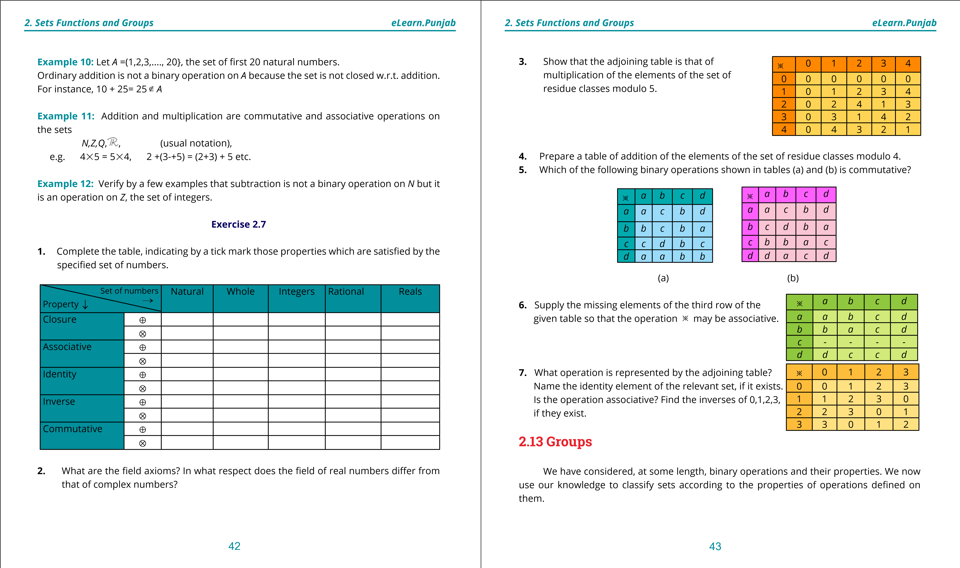

**1. Quadratic Equations eLearn.Punjab 1. Quadratic Equations eLearn.Punjab *2. Sets Functions and Groups eLearn.Punjab 2. Sets Functions and Groups eLearn.Punjab***

First we state a few preliminary deinitions which will culminate in the deinition of a group.

**Groupoid:** A **groupoid** is a non-empty set on which a binary operation %.... is deined. Some authors call the system (*S*, %.... ) a groupoid. But, for the sake of brevity and convenience we shall call *S* a **groupoid**, it being understood that an operation%.... is deined on it.

In other words, a closed set with respect to an operation %.... is called a groupoid.

**Example 1:** The set {*E* ,*O*} where *E* is any even number and *O* is any odd number, (as already seen) are closed w.r.t. addition. It is, therefore, a groupoid.

**Example 2:** The set of Natural numbers is not closed under operation of subtraction e.g.,

For 4, 5*dN*, 4 - 5 = -1∉ *N*

Thus (*N*, - ) is not a groupoid under subtraction.

**Example 3:** As seen earlier with the help of a table the set {1,-1,*i*,-*i*}, is closed w.r.t. . multiplication (but not w.r.t. addition). So it is also a groupoid w.r.t %.

**Semi-group:** A non-empty set *S* is semi-group if;

i) It is **closed** with respect to an operation %.... and ii) The operation is %.... **associative.**

As is obvious from its very name, a semi-group satisies half of the conditions required for a group.

**Example 4:** The set of natural numbers, *N*, together with the operation of addition is a semigroup. *N* is clearly closed w.r.t. addition (+).

Also " *a,b,cdN, a + (b + c) = (a + b) + c*

Therefore, both the conditions for a semi-group are satisied.

**Non-commutative or non-abelian set:** A set *A* is non-commutative if commutative law does not hold for it.

For example a set A is non-commutative or non-abilian set under%.... when is deined as:

" *x, ydx*%.... *y = x.*

Clearly *x*%.... *y* *= x* and *y*%.... *x = y* indicates that *A* is non-commutative or non-abilian set.

**Example 5:** Consider *Z*, the set of integers together with the operation of multiplication.

Product of any two integers is an integer.

Also product of integers is associative because "*a,b,cdZ* *a.*(*b.c*) *=* (*a.b*)*.c*  Therefore, (*Z*,.) is a semi-group.

**Example 6:**  Let *P*(*S*) be the power-set of *S* and let *A,B,C,* ... be the members of *P*. Since union of any two subsets of *S* is a subset of *S*, therefore *P* is closed with respect to ~ . Also the operation is associative.

(e.g. *A* ~ *( B* ~ *C ) = ( A* ~ *B )* ~ *C* , which is true in general), Therefore, (*P*(*S*),~) is a semi-group.

Similarly ( *P*(*S* ),*+*) is a semi-group.

**Example 7:** Subtraction is non-commutative and non-associative on *N*.

**Solution:** For 4, 5, 6,*dN*, we see that

4#5 =#1 and 5#4 = 1 Clearly 4#5 ≠ 5#4

Thus subtraction is non-commutative on *N*.

Also 5#(4#1)= 5#(3)=2 and (5#4)#1 = 1#1 = 0

Clearly 5#(4#1) ≠ (5#4 )#1 Thus subtraction is non-associative on *N*.

**Example 8:** For a set *A* of distinct elements, the binary operation%....on *A* deined by *x*%.... *y* = *x*, " *x, ydA* is non commutative and assocaitve.

**Solution :** Consider

*x*%.... *y* = *x*  and y%.... *x* = *y*

Clearly *x*%.... *y*  ≠ *y*%.... *x*

Thus %.... is non-commutative on *A*.

**Monoid:** A semi-group having an identity is called a **monoid** i.e., a monoid is a set *S*; i) which is closed w.r.t. some operation%.... . ii) the operation%.... is associative and

44 45

**1. Quadratic Equations eLearn.Punjab 1. Quadratic Equations eLearn.Punjab *2. Sets Functions and Groups eLearn.Punjab 2. Sets Functions and Groups eLearn.Punjab***

iii) it has an identity.